Teacher Information and
Program Guide

Dear Visiting Teacher

Welcome! Your participation in the outdoor education programs at the Etobicoke Outdoor Education Centre will enable you and your students to discover the natural environment through hands-on, inquiry based experiences in the out-of-doors. The overnight format of this program should provide a unique and lasting educational experience including opportunities for teachers and their students to get to know one another better and build rapport, respect and trust.

Our objective is for you to make the outdoor experience a complimentary part of your regular classroom-learning program. The natural environment can serve as a setting to develop and support your entire classroom curriculum. It will enrich your learner's total education and is meant to further the learning they are experiencing at school!

As with any field trip or experience outside the classroom, good planning and preparation play a vital role in the ultimate success of the venture. A comprehensive set of program and pre-planning materials have been developed to help you prepare yourself and your students effectively for the upcoming visit. The remainder of this book will assist you in your preparations and outline your responsibilities during the visit. Your first visit should be to our comprehensive website which contains an information video and program descriptions of programs. Click Here

You will receive notice from your school’s principal in the near future with regard to the applicable user fee that will be required to attend the overnight experience at the Etobicoke Outdoor Education Centre. This fee is only a small portion of the full cost of an overnight visit and is in recognition that the TDSB has supplemented the costs. No student shall be denied a trip as a result of financial constraints. Please contact the Centre if there are any concerns. Funds are to be collected by the school and the school will be sent an invoice after the visit. Payment through a budget transfer is required. Cheques will not be accepted.

Please don't hesitate to telephone us to talk over any organizational or program concerns. (905) 880 -1890 or email lori.yez@tdsb.on.ca

We are confident that this experience will be rewarding and memorable for both you and your students. We look forward to working with you and your class.

Yours Truly,

Lori Yez
Site Supervisor
905 880 1890
lori.yez@tdsb.on.ca

E.O.E.C. MISSION STATEMENT

The mission of the Toronto District School Board Outdoor Education Schools is:
- To provide safe, active, and enriching learning experiences
by immersing students and staff in natural and urban environments.
- To enable participants to practice personal responsibility and develop respect for self, for others, and for their world.

Our goal at the E.O.E.C. is: “To Inspire Everyone By Bringing the Classroom Outdoors”

AIMS OF THE PROGRAM

Participation in this program will give students the opportunity:

1. To develop an appreciation and respect for all living and nonliving components in the natural environment;

2. To develop an awareness, through direct contact, of human dependence upon the natural environment and to develop an understanding of the natural environment as an ecosystem

4. To develop scientific investigative skills using a variety of techniques in a natural setting

5. To develop a sensory awareness of the natural world around us

6. To develop global competency skills outlined with the TDSB Vision for Learning
https://sites.google.com/tdsb.on.ca/globalcompetencies/getting-started/quick-guide-checklist

7. To develop skills in using the natural environment for recreational pursuits

8. To develop an awareness of environmental issues which upset the balance of our ecosystems and examine these with higher order, critical thinking skills

OUTDOOR EDUCATION PROGRAM

A wide variety of activities can be included under the classification of Outdoor Education. Generally, the activities we offer fall into three main areas of focus.

A. Environmental Studies
- Studies that include both science and geography.

B. Cultural and Historical
- Studies dealing with the present or past ways of living in Canada.

C. Recreational
- Activities associated with leisure pursuits.

ENVIRONMENTAL ETHICS

When large numbers of people use an area consistently, over a period of time, the environment will react to this usage and some changes result. In order to minimize these changes, we have adopted a code of environmental ethics. One of the aims of our program is to instill in the students a respect for the outdoor environment and all of the components within it. In addition to discussing environmental ethics with the students we role model our expectations.

- Do not pick up or collect anything - even moss and fungus are alive! There will be occasions when Centre staff will encourage you to touch or smell specimens, however, please remember not everything is safe to touch.

- If you use natural objects for an activity, replace them in the exact location where they were found. Leave the area looking just as it was when you arrived.

- When walking through an area, stay on the established paths and walk in a single line to minimize the impact upon the trees and plants of the surrounding area. Be careful where you step - especially in environmentally sensitive areas.

- It is unacceptable to leave litter on the ground. We all need to make an effort to be custodians of our surroundings.

- Any animal encountered by groups should not be handled because of the potential of diseases being transmitted to students.

- We would like to encourage Centre students to think globally, to act locally and to understand the abstract, “Live gently on our Earth”.

Please take the time to discuss the above points with your students prior to the excursion
Take only pictures - Leave only footprints

FACILITIES AT THE OUTDOOR EDUCATION CENTRE

The Centre is located in the Albion Hills Conservation Area 6.4 km north of Bolton off Highway 50. The site offers 450 hectares of hardwood bush, reforestation areas, and open parkland. The west branch of the Humber River and its tributaries wind their way through the property. The natural history and scenic beauty of the area make it a prime resource for the purposes of environmental education.

Our Overnight Centre is located near the western boundary of the conservation area. The building contains a common room and reading area for students and a fully equipped instructional area. There are separate male and female dormitories containing eight bedrooms, which hold a maximum of four students each. Washroom and shower facilities are located in each of the dormitory areas. A staff bedroom with two beds and an ensuite washroom is also located in each of the dormitory sections. Staff and students enter the building through the mudroom, which contains outdoor clothing storage facilities and a boot/equipment storage area. As well, the main floor has washrooms, a teacher preparation area, an office, and equipment storage areas.

ACCESS TO THE ALBION HILLS CONSERVATION AREA
AND THE ETOBICOKE OUTDOOR EDUCATION CENTRE

The most direct route to the Etobicoke Outdoor Education Centre is as follows:

- north on Highway 427 to the end of the Highway

- go left west (left) approximately 1 km

- go north (right) on Highway 50 through Bolton

- continue approximately 7.0 km north of Bolton, past Old Church Road. Turn left into the Albion Hills Conservation Area

- once you enter the Conservation Area, follow the signs to Field Centre. At the T-junction you will turn left. Continue past the pool/splash pad until you reach a fork in the road. Veer left to the Etobicoke Outdoor Education Centre. We are located halfway up the hill on the right hand side.

SEE MAP NEXT PAGE

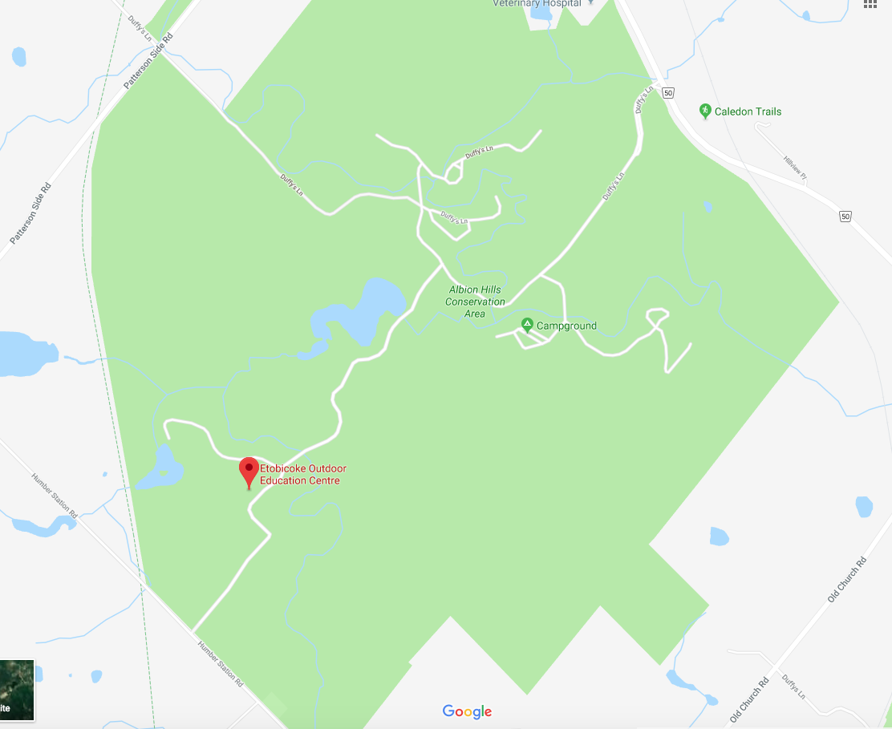

CLASSROOM TEACHER'S RESPONSIBILITIES AT THE CENTRE

An atmosphere of shared responsibility is the approach that is expected of both
the Centre staff and the Home School Teacher in carrying out supervision duties at the EOEC.

1. Some participation in the program will enhance the learning opportunities for all visitors, as such you will be scheduled to accompany your students during their outside activities so that you may enjoy the same outdoor experiences, which will enable you to enhance your follow up activities back at school.

2. As this is an overnight visit, Home School Teachers are expected to supervise:

- the storing and distributing of any learner medication as
indicated on the learner medication form

- the shower, lights out, and overnight periods
Please note that the excursion policy states that there must be
Supervisors of both genders on the trip at a ratio of
15 students to 1 Supervisor

- the period before and after breakfast

- students indoor/outdoor free times including evening home school time

- pre-departure packing and clean up routines

- meals and snack time (in conjunction with centre staff)

3. If damages to or losses of TDSB property occur while at the Centre it is the responsibility of the E.O.E.C. staff in collaboration with the Homeschool Teacher, to report the incident to the Home School Principal, so that restitution may be arranged if necessary.

OVERNIGHT CENTRE RULES AND ROUTINES

During your visit to the Centre we expect that both staff and students will treat the facility with the respect that they would show when staying as a guest in someone else's home. If everyone follows these basic rules comfort and safety will be ensured for all.

A. DORMITORY AREAS

- Bedrooms are to be used for sleeping and changing only. Any socializing must take place in the common room or outside. Students found in the dormitory of the opposite sex will be immediately removed from the program and further discipline may be taken (including the strong possibility of going home)

2. Students are allowed only in the bedroom assigned to them.

3. The dormitory and washroom areas must be kept neat and clean at all times.

4. All outside footwear, coats and hats must be removed and properly stored on the designated racks and hooks in the mudroom area.

B. COMMON ROOM

1. Displays, games, books and magazines are available for learner use. Please replace any items in the proper location after use.

2. If it is necessary to rearrange the furniture for any reason, please ensure that it is put back in its proper place when you have finished your activities.

C. DINING ROOM

1. It is extremely important that meals start on time because we share the dining facilities with another group. Leaving the EOEC 10 minutes before meals start is necessary.

2. Special dietary considerations should be discussed no later than 2 weeks prior to your arrival at the Centre so that special arrangements may be made if necessary.

3. Students will have setting, serving, and cleaning duties to perform at each meal. Table setters will arrive 15 minutes prior to each meal and remain 15 minutes after.

4. Talk quietly with the people at your table.

5. Neatness and cleanliness in the dining hall is the responsibility of everyone.

D. OUTDOORS

- During recreational periods the students must stay in the designated areas where they can be properly supervised by their Home School teachers.

- All water areas are out of bounds.

- Any equipment borrowed for sports activities must be returned to the proper storage area after use.

E. SMOKING AND ALCOHOLIC BEVERAGES

- The Board regulations do not permit the use of alcohol or smoking on school sites.

F. FIRE REGULATIONS

- Students and visiting staff will be introduced to and participate in fire safety procedures and routines at the EOEC.

- When a fire alarm sounds:

- All students and staff clear the building immediately through the nearest exit;

- All students and staff will then meet in the parking lot for a head count to ensure no one has been left in the building.

TEACHERS PLEASE NOTE!

Students found to be in possession of cigarettes, alcoholic beverages, or illegal drugs will be removed from the program. In addition, students entering the wrong dormitory (boys in girls’ or girls in boys’) will be removed from the program. In these unfortunate circumstances, parents of the affected students will be requested to come to the Centre to take their child home. These situations are not common occurrences at the Centre, yet the staff of the Centre wishes teachers and parents to have full knowledge of these procedures. Transportation home will be at the expense of the families involved.

EMERGENCY PROCEDURES

The following information is presented to the home school teachers to familiarize them with a course of action, should an emergency arise. Our Centre is well equipped with first aid supplies and our staff members are trained in administering first aid. We are very conscious of possible injury and strongly believe in accident prevention. We share your concerns for the health and safety of your students!

A. IN THE CASE OF LOST PERSON(S)

All staff will carry a whistle whenever they are away from the residential Centre. All staff are urged to keep a constant 'headcount' so that the absence of a learner is quickly noted, especially during winter conditions.

As part of the 'Learner Introductory Session' at the Centre, the students are instructed to remain where they are as soon as they realize they are lost. Instead of trying to find their

own way back, the students are encouraged to listen for a staff’s whistle signal (three blasts repeated at intervals) which indicates "I am looking for you".

The search will incorporate:

- a search of the immediate area including the building;

- a whistle-walk to surrounding areas;

- a drive along the nearby roads;

- supervision of students at the Centre during the search is the primary responsibility of the Homeschool staff.

B. IN THE CASE OF INJURY
- If an injury is considered serious, an ambulance will be contacted to transport the learner to the nearest medical facility. All injuries will be treated IMMEDIATELY in accordance with first aid procedures.
- When medical attention is considered necessary, but not an emergency, an EOEC staff member, accompanied by one of the Home School staff, will take the learner to the emergency ward of William Osler Health Centre (formerly Etobicoke General Hospital) or Headwaters Health Centre (Orangeville).
- Parents will be notified that the learner is being transported to the hospital and asked to meet staff/learner there.
- The Homeschool Teacher will then relay the information to the Home School Principal.

C. IN THE CASE OF SICKNESS

- If a learner becomes 'noticeably' sick he/she will be isolated and kept under supervision. If he/she does not seem to recover after a reasonable time, the Homeschool Teacher will contact the parents and principal. Arrangements will be made with the parents to transport the learner home.

- If this is not feasible, the Home School will send a representative to the Centre to pick up the learner.

- If the learner's condition is judged to be serious and immediate medical attention is necessary, the learner will be taken to the nearest hospital. The parents and the principal will be notified immediately.

D. IN THE CASE OF BEING WEATHERED IN

If the staff and students are unable to leave the Centre, the Home School Teacher will call the home school to alert them of the delayed departure. We cannot transport students if the busses to TDSB or Peel District School Board (in the Town of Caledon) schools have been cancelled.

E. IN THE CASE OF POWER OR HEATING FAILURE:

The Centre staff will determine whether the situation is short or long term. If essential services can be maintained and no danger exists, the program will continue.

If the problem is severe or "may become severe", the residential staff will recommend that transportation home be arranged.

The Homeschool Teacher will alert the school by telephone about the students early return. The school will then pass this information to the parents.

F. IN THE CASE OF FIRE:

As part of the "Learner Introductory Session', the students are instructed about their role should a fire occur. The primary concern is to clear the area, not to attempt to fight the fire.

The Centre is equipped with fire alarms, smoke detectors and fire extinguishers. All staff members are familiar with the location and use of fire extinguishers.

For the purpose of a head count, up-dated learner lists will be readily available at all times.

If the fire alarm does sound, all students and staff will clear the building immediately through the nearest exit and assemble in the parking lot for a head count to ensure no one has been left in the building.

COMMENTS

We hope that this handbook has been helpful to you in making preparations for your Outdoor Education experience. It is very important that you are familiar with the program, your responsibilities, and the general routines of the Centre in order for your visit to be truly successful. If any further questions arise, give us a call anytime at the Centre. (905 880 1890)

The staff at the EOEC welcomes responses from students and teachers after their visit. We would like to hear your feedback. Our program is responsive to your needs and we need to hear from you to determine new directions.

EQUIPMENT AND CLOTHING CHECKLIST

Please Label All Articles with Your Name
Please remember we are a Scent Free Facility

The Centre will provide raincoats and rubber / winter boots for those students who require them.

Please bring a nut free waste-free lunch for the first meal and a water bottle for use during the week.
Toiletry Items and Bedding  - Comb and Brush  - Toothbrush and Toothpaste  - Soap in a plastic container  - Facecloth  - Hand Towel  - Bath Towel  - Deodorant  - Shampoo  - Pillow  - Clean Pillow Case  - Sleeping Bag or 2 Sheets and a Blanket  Optional  - Sunscreen  - Mosquito Repellent (less than 10% deet)  - Camera  - Lip Balm  - Garbage Bags for Dirty Laundry  - Shorts/Sandals for Free Time  - Books/Magazines  - Quiet Games (non-electric)  - Musical Instruments  Please note that EOEC will be providing evening snack. | General Clothing  - Pyjamas  - Indoor Shoes or Slippers  - Underwear  - Socks (bring extras)  - 2 Sweaters or Sweatshirts  - 2 Pair of Pants (Jeans or Sweat Pants)  - 2 T-Shirts or Long sleeve shirts  Outdoor Clothing  Fall/Spring:  - Rain Hat  - Rain Coat  - Rubber Boots  - Bug Jacket (or light coloured outer layer)  Winter:  - Heavy Winter Coat  - Waterproof and Lined Winter Boots  - Mitts (warm, lined and waterproof)  - Snow Pants  - Winter Hat  - Scarf  - Long Underwear  - Heavy Socks
Please Do Not Bring the Following:
- Snacks, Gum, Candy, Beverages (other than what will be consumed during the first lunch  - Electronic Music Players, Games, Cell Phones, Money | - Cologne, Perfume, Scented Lotion  - Matches, Knives, Hatchets, Firearms  - Cigarettes, Alcohol, Illegal Drugs  - Non-prescription Medication
Please note: The E.O.E.C. is not financially responsible for any lost or stolen items.

SAMPLE DAILY SCHEDULE

Time Activity

6:45 - 7:20 Wake-Up
7:15 Table Setters over for breakfast set up
7.20 Leave for Dining Hall
7:30 - 8:30 Breakfast
8:30 - 9:00 Clean Rooms and Morning Chores

9:00 - 11:15 Morning Program

11:15 Table Setters for Lunch
11:20 Leave for Dining Hall
11:30 - 12:30 Lunch
12:30 - 1:00 Free Time

1:00 - 4:15 Afternoon Program

4:15 - 4:50 Free Time
4:45 Table Setters for Dinner
4:50 Leave for Dining Hall
5:00 - 6:00 Dinner
6:00 - 6:30 Free Time

6:30 - 8:15 Evening Program

8:15 - 8:30 Snack (provided by EOEC)
8:30 - 9:30 Home School Time
9:30 - 10:00 Dorms, Showers, Etc.
10:00 Lights Out

*Please note that this is only a sample day and changes may occur - i.e., times may vary depending on group size, programs and weather conditions.

INTRODUCTION SESSION FOR STUDENTS

TEACHER'S COPY

- Why are you here?

a) to learn about nature
b) to develop respect for nature
c) to grow - to co-operate, make new friends, etc. (Character Traits, Global
Competencies)
d) to enjoy yourselves and the natural environment.

2. This is a school. You must abide by the same rules as in your regular school i.e., raise your
hand before speaking.

3. Key Words - Listen and co-operate.

4. Attention signal - when a teacher raises his or her hand everyone must stop what he or she
is doing, raise his or her hand and be quiet. (Quiet Coyote or staff yell EO, students respond
EC

5. Dorms are for sleeping and changing clothing only.
- Socialize in the Common Room or outside. Boys - girls' dorm out of bounds. Girls – boys’ dorm out of bounds.
- You are not allowed in any dorm room other than your own. If you must speak to someone you do it in the common room or in the dorm hall.

6. No food is allowed in the dorm rooms. Hand in all snacks, gum etc., at the end of
introduction and it will be returned before you leave.

- All medicine, except for inhalers and epi-pens, should be given to your home school teacher.
He or she will administer it when needed.

8. Mud Room: Always enter and exit via Mud Room door
- indoor and outdoor shoes stored in cubicles, not in rooms
- coats and hats hung on hooks.
Please do not wear outside shoes inside.

9. Washrooms: Our plumbing is on a septic system, therefore, we must try to conserve water i.e. while brushing your teeth, showering, etc.
- Showers after snack only. No showers during the day.

10. Morning chores - A list will be posted in the Common Room indicating who is on Morning Chores. Each dorm will have its turn tidying up the mud room or feeding the birds.

SAFETY:

- Lost - stay where you are and hug a tree, three whistle blasts mean we are looking for you.
- Fire - fire alarm is a loud, ringing bell. Exit quickly through the nearest exit and meet in
the parking lot. Do not go back into the building to look for friends. The staff will do
- any necessary searching.
- If in dorm room, feel the door to see if it is hot before exiting.
- There are emergency exits at the end of each dormitory hallway.

12. Please walk inside the building. All running and active play done on the field behind the building.

13. Conservation - turn off your dorm light and fan, don't waste water etc.
Please do not pick or damage plants and wildlife.

14. Free Time: During free time, you are encouraged to play outside within sight of the
building. Do not cross any roads during free time.

15. Piano – with permission from EOEC staff, feel free to entertain your classmates if you can
play a tune but not before 8:30 am or after 9:00 pm.

16. Dining Hall: You must carry your indoor shoes over to the dining hall.
Table setters will meet a centre staff member at the mud room doors 15 minutes before each meal to help set up the dining room and they will stay after the meal to sweep up.
Meal times: It is important to start meals on time because the dining room is shared with the group staying at the Albion Centre. In order for meals to begin on time, you should leave the centre at the following times:

Table Setters Rest of the class
Breakfast 7:15 7:20
Lunch 11:15 11:20
Dinner 4:45 4:50

When you arrive at the dining hall, wait in the mudroom until the teacher lets you in. When you enter the dining room you stand quietly at a seat. No sitting, talking or eating until after the EOEC staff have given the instructions.

*further instructions regarding meals are given during the first lunch.

