Flemington Public School

Flemington Public School
10 Flemington Road
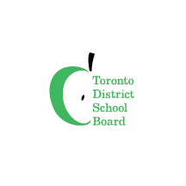
North York, ON M6A 2N4
416-395-2430 or 416-997-6400
Register today!
Visit our elementary summer school website to fill out an online application form, or go directly to URL <www.tdsb.on.ca/summer> and click on the elementary summer school button.

Come and learn with us this summer!

Date: July 4 to July 29, 2022
Time: 9:00 a.m. to 3:00 p.m.

Our In-person Program will focus Literacy and Numeracy infused with Mindfulness, Arts, Character & Social Justice Education

Summer School Principal
CherylAnn Samuel-Graham
cherylann.samuel-graham@tdsb.on.ca

