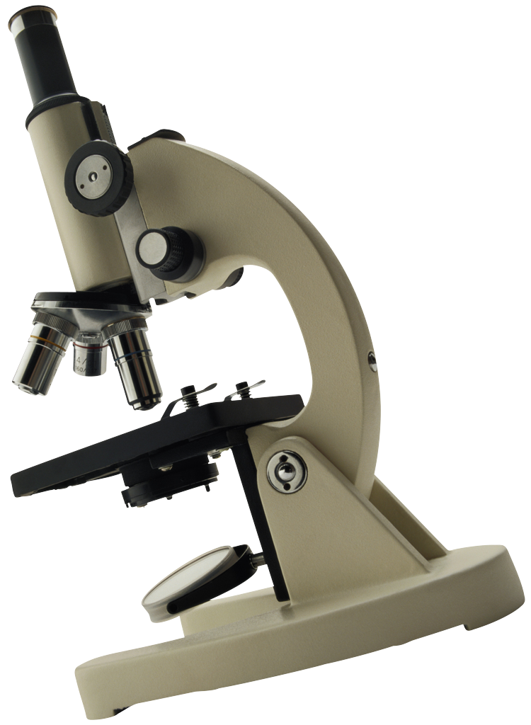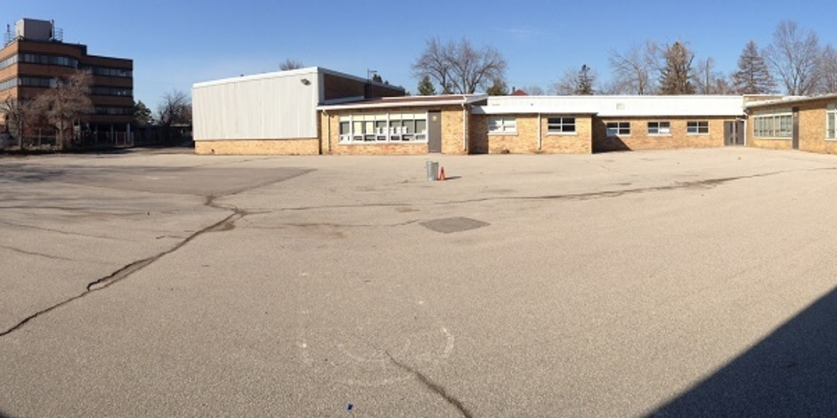

#### RESPECT

This month we will be focusing on respect. Our class will be responsible for coming up with quotes that will be read daily on the announcements as well as organizing and presenting at this months assembly.

Respect for ourselves guides our morals, respect for others guides our manners.

Laurence Sterne

First up this year we will be focusing on recounts as well as data management, Science and cooperative games.

This year we will be piloting an app called Sesame. Each student will have their own code so they can access their own area to take pictures of, and log their work throughout the year. It is essentially a digital portfolio. More information to follow.

I expect a lot from my students. Most importantly, I expect that they are respectful of their teachers, peers and themselves. I invite them to come to me with any concerns and we will work together to find a solution.

To start the year, students will be encouraged to read for at least 20 minutes each night and record it in their reading log. We will add to this as the year progresses. As well, if you are looking for additional work, practicing the multiplication tables would assist during Math.

If you have any concerns or questions I can be reached at the school at 416 396-6300. I will do my best to get back to you as soon as possible.

The school day runs from 8:55 – 3:30. If for any reason you need to pick up your child early, please go to the office and ask for them to be called down and wait for them there. This will prevent disruptions to the learning environment. Your attention to this is very much appreciated.

Thank you!

## Housekeeping

Welcome Back!

I hope that you all had a great summer! I’m so excited to start the new year and hope that you are too! I am looking forward to teaching each and every one of you!

# Ms. McMichael’s Grade ¾ Class 2015-2016

#### What’s Happening

### September 2015

WElCOME BACk