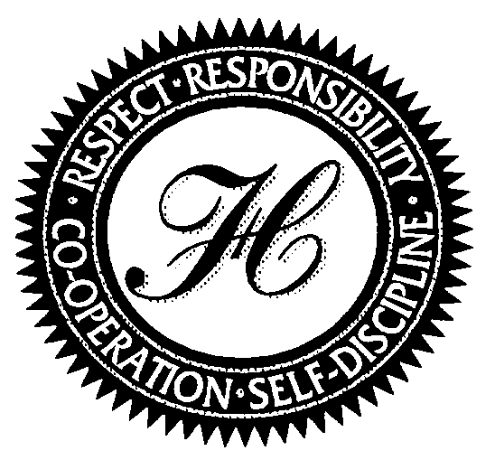 | H.A. HALBERT JR PUBLIC SCHOOL  31 McCowan Road, Scarborough, Ontario M1M 3L7  Telephone (416) 396-6300  Safe Arrival: 396-3298  Principal: Nicole Miller, B.A., M. Ed. | 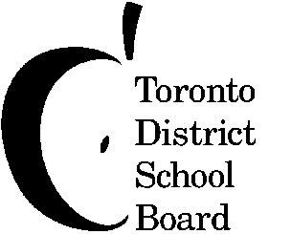

Student Nutrition Added Program (S.N.A.P.)
SNACK PROGRAM

What is S.N.A.P.?
S.N.A.P. is our very own Student Nutrition Added Program. It is also known as the snack program. With the support from the “Toronto Foundation for Student Success”, H.A. Halbert P.S. will be starting a healthy snack program. It is our goal to provide a nutritious snack to students from grades JK to 6, two days a week beginning Tuesday October 1st, 2013.
Why offer a snack program?
Research and studies have shown that children, even more than adults, need to have nutritious food in the morning because of their high metabolic rate. Without adequate morning nutrition children suffer from fatigue, irritability, stomach cramps and headaches and an inability to concentrate, which prevents them from learning.
What type of snacks will be served?
Our plan for this year is to offer a selection of healthy foods from as many of the four food groups as possible. Students will receive various foodstuffs (keeping in mind the dietary restrictions of our students). Dairy based snacks include milk, yogurt and cheese. All food served is Halal.
Who will pay for the snacks?
“Toronto Foundation for Students Success” has provided us with some funding for snacks. As well, we ask families to contribute $10.00 monthly per child or send a cheque for $90.00 to cover to the end of June this school year.
All students are asked to contribute $10.00 per month to June and a tax receipt (for contributions of 10.00 or more) will be forwarded to you through the Toronto Foundation for Student Success (if requested).
How do we start?
We have attached a registration form with this information sheet. Please fill in one form for each child and return it to the school by: Monday September 30, 2013 at the latest. Forms can be sent in starting immediately.

YOUR CHILD CANNOT RECIEVE A SNACK WITHOUT THE REGISTRATION FORM
The contribution for your child can be sent with the registration form(s).

Cheques are made payable to
Toronto Foundation for Student Success (TFSS)

H. A. Halbert Public School
Student Nutrition Added Program (S.N.A.P.)
SNACK PROGRAM

REGISTRATION FORM for H.A. Halbert’s Student Nutrition Added Program (S.N.A.P.)
(Please print clearly)

Students Name _______________________________________________________________

Teacher ________________________________ Grade _______ Room ________

Please list any health or dietary concerns for your child by answering the following questions.

Does your child have any dietary restrictions?

Is your child allergic to any nut, milk/dairy products? List allergies your child has:

A contribution envelope will be provided to all students monthly.
Please submit your contribution in the sealed envelope and return to your child's teacher.
If donating by cheque, PLEASE make cheques payable to T.F.S.S. (Toronto Foundation for Student Success)
A tax receipt will be given for all donations of $10 or greater.

€ YES my child will participate in the Student Nutrition Added Program (S.N.A.P.)
€ NO I do not want my child to participate in the Student Nutrition Added Program (S.N.A.P.)

Name of Parent (please print)

Parent's/Guardian's Signature

Date

VOLUNTEER OPPORTUNITY
I would be willing to assist the program by volunteering 1-2 hours/week: € Yes € No

If you are able to volunteer, please print your name, address and telephone number

Name:

Address:

Telephone Number(s):

Thank you for completing this form and returning it to your child's teacher.

