Island School Reflections

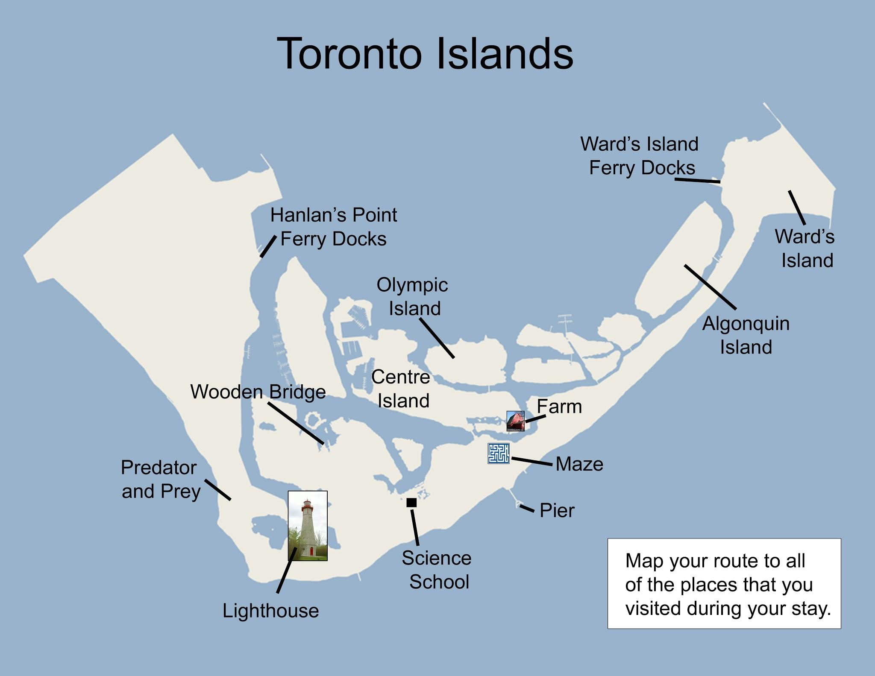

- Use the map and the space below to describe memorable moments during your trip!
LEGEND

- Why do you think your class on a field trip to the Island school?

- What would you like to learn?

- “What is your place in the natural world?”
All our lessons are tied to this question. Use pictures, words and symbols to illustrate your ideas.

