Gibraltar Point Lighthouse (Drama)
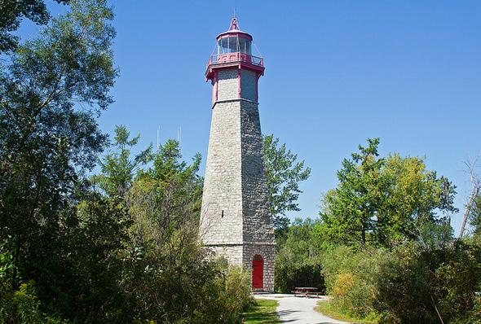

The Gibraltar Point Lighthouse is part of a long history of the Toronto Islands. Many people, animals, weather and centuries have been a part of this history. While much of the Island’s history remains unknown, it is important that we acknowledge what came before us and what the future may hold. Here’s a challenge: Instead of seeing ourselves as the end of a timeline, imagine us as visitors or guests in this place. How might this change our perspective?

1. Why do you think we retell stories from our past?

2. a) What familiar story or movie reminds you of the Lighthouse story?

b) How are they similar?

3. a) If you could meet one character from the story, who would you like to meet?

b) Why?

4. In pairs, write a script for an interview with one of the characters from the movie (i.e. J.P. Rademueller, British Soldiers (Smith/Russell), William Elder (indigenous fisher).

5. Choose one point in the story where you become J.P. Rademueller and make different choices.
a) Describe what you would do differently and what choices you would make.

b) How would this affect the story’s outcome?

