Parent/Teacher Conference Scheduling
http://jci.schoolappointments.com

Parent Registration
Parents click on the “Register” tab and fill in the registration form to create an account.
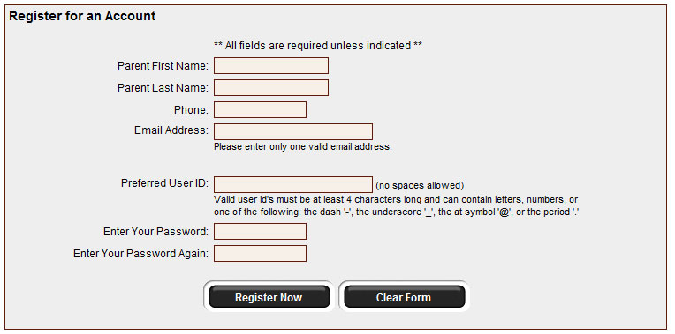
Once parents have successfully registered, they will be logged into the system and can register their students.
Parent Appointment Scheduling
Parents can schedule appointments for any student that they have added to the system by clicking on the “Appointments” button beside the student’s name. The parent is then taken to a page where they can select the teachers with whom they wish to meet. Multiple teachers can be selected by using the “Ctrl” key on a PC keyboard or the “Command” key on a Macintosh keyboard.
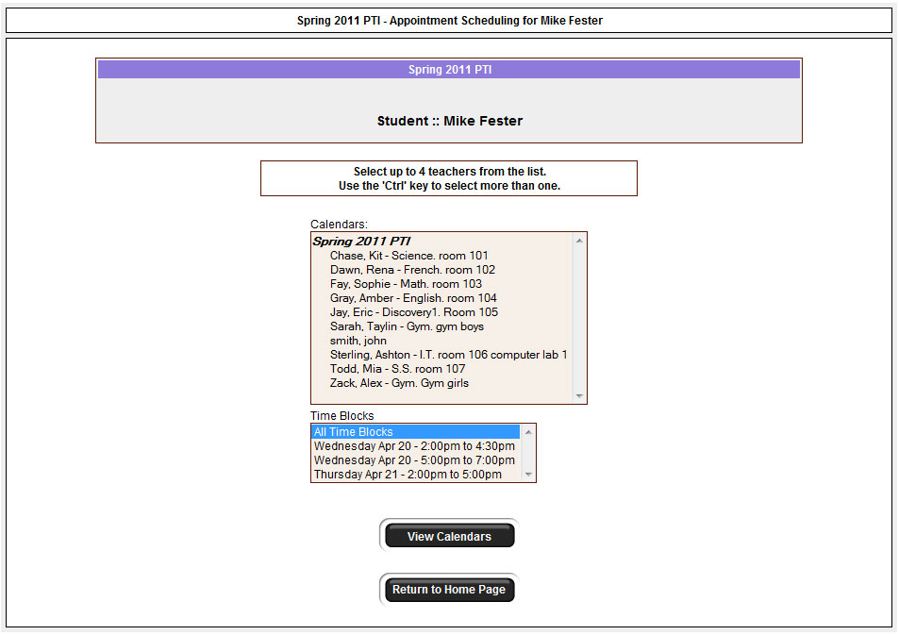
Teacher Appointment Calendars
Next, parents are shown the calendars of the selected teachers.
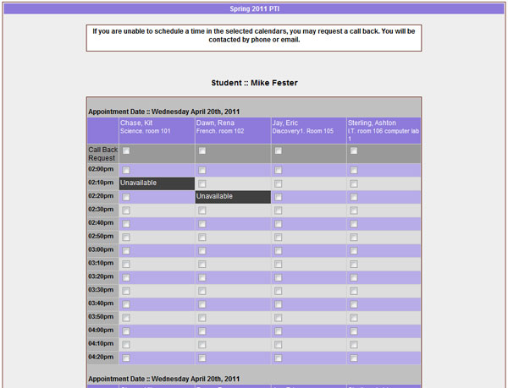

The calendar above displays the appointment calendar for four teachers, and shows various appointment times that are unavailable for booking.
Parents can select appointment times by simply clicking the check boxes or by clicking in the time block beside the check box. Once an appointment time has been selected it will change to green.

Teacher Appointment Calendars with Appointments Selected

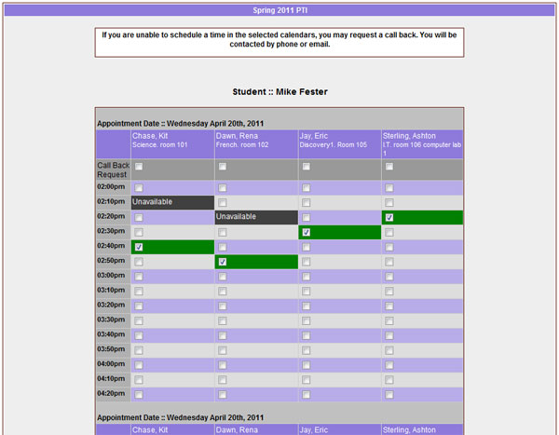

It is not possible for parents to select more than one appointment at the same time or to select more than one appointment with the same teacher. Javascript enabled browsers are required for this validation on the screen. If a parent uses a browser without Javascript enabled and attempts to schedule appointments with a conflict, the next screen will notify them of the errors.

Appointments Booked Successfully
Once the appointments are booked the screen will display the list of appointments for the student.

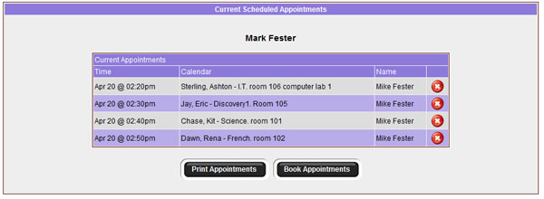

Parents with More Than One Student
If a parent has more than one student at your school the teacher appointment calendars will have an additional feature displayed when the second (or third, etc.) student bookings are made.
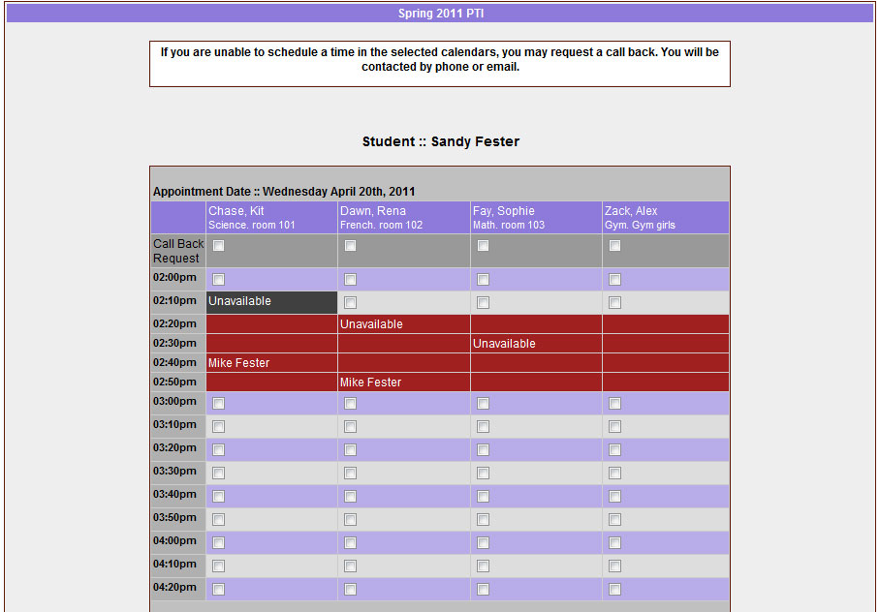

This calendar displays the appointment times for four teachers and shows “Unavailable” appointment times and there is a region that cannot be booked as these times have been scheduled already for another student, “Mike”, and this parent is already busy at these times. Only if a sibling has an appointment booked, will the student’s name be displayed for a parent, thus making it easier to book adjacent appointments.

Printing Parent Appointment Schedule
From the home page it is possible for parents to generate a PDF document with the list of their appointments. By clicking on the “Print Appointments” button a window will pop-up asking the parent what they wish to do with the document.
In Internet Explorer it is recommended that people click the “Save” button, save the file and then click “Open” to view the file. IE sometimes has a problem downloading and opening PDF documents that are generated from web sites.

Click “Open” after the download is complete to view the PDF.

Parent Schedule PDF
If the parent has done well with their scheduling they will have a nice set of consecutive appointments. The generated PDF will list the appointment times, the student and the teacher with whom the appointment is booked.


