Information about happenings at John Fisher, including an up to date school calendar, can be found at http://schoolweb.tdsb.on.ca/johnfisher/home.aspx You can also follow us on twitter at @JFLPenguins
We are working on building our “Squawk” list for 2015-16. Anyone wishing to be added to the list, please email lee-anne.maier@tdsb.on.ca, be sure to include the name and class of your child.
TERRY FOX: We are celebrating our 10th anniversary next week!
This is reminder that our kick-off assembly is on Friday, September 25 at 1:00 and will include the much anticipated Cut-off-Cancer event where volunteer students donate their own hair to help make wigs for cancer patients. If your child in interested in participating this year, please read the information below and let the organizers know.
The day of the run will be Wednesday, September 30th. Classes will come out in shifts throughout the day- a schedule went home in this week’s Thursday envelopes. Please consider coming out to volunteer that day. It is truly inspiring to watch our students run "Just like Terry"!
Please contact Erika Boone at theboones@sympatico.ca if you are interested in volunteering.
The Cut-Off Cancer campaign has become hugely popular. Many students have donated their hair over the past few years to help make wigs for cancer patients. Students need to have at least an 8 inch ponytail to donate and, of course, the permission of their parents. Students can decide to have their hair cut privately and bring it to the assembly. Some students have their hair cut on stage in front of the school at our annual Terry Fox kick-off assembly. We have stylists on hand to help with the process and give haircuts to our brave students. If you are interested and/or have questions please contact Benita at benita_w@yahoo.com. The Terry Fox assembly will be Friday, September 25 at 1:00.
Our Grade Four students are preparing to sing the Terry Fox song at the kick off assembly. See the link below to listen to and practice the song at home! could post this video on squawk or twitter, it's got great footage of Terry F ox and includes lyrics to get kids excited for the event, and also for the 4s to practice at home!

http://youtu.be/nwpzXxU7VWk

PICTURE DAY!
Say cheese! Picture Day will take place on Thursday, October 1.
STUDENT SAFETY

Safety is always our number one priority. As such, we kindly ask that you please do the following:
- Please begin your visit at the main office. It is imperative that we know who is in our building at all times. As well, please do not meet your child on the school yard during the instructional day. Please go to the office and we will be glad to assist you.
- Our school is locked access. All visitors must come to the front door. Please refrain from using other doors as they are for our students and staff.
- Pick-up and drop-off has been going quite well these past couple of weeks and we thank you for that! Just a friendly reminder to be extra careful in our school zone and to leave the bus zone vacant at all times.

SCHOOL PARKING

Our school parking lots are reserved for staff from 8:00 AM - 4:00 PM daily. We thank you in advance for your cooperation.

PARENT COACHES
Parent Coaches are a vital part of our school community. The TDSB and our athletic association (TDESSA) are now offering a Community Coaches’ Meeting to review the TDESSA code of conduct and philosophy of sport. Please see the attached letter to attend one of these sessions. As well, interested people can pick a form up in the office. (We are part of the north sessions.)

CROSS COUNTRY
Cross Country season is well underway. Thank you to our parent volunteers and M. Masko for leading this program! Practice takes place at Sherwood Park on Tuesday and Thursday mornings for students in grades 4 - 6. Runners are asked to GO DIRECTLY to Sherwood Park for the 7:45 training session. Staff and parent volunteers will be onsite to receive students and organize the practice. Following the practice, students will be supervised to walk back to the school in groups. As such, parents need to ensure their child is dropped off at Sherwood Park at 7:45 and we will do the rest!!!

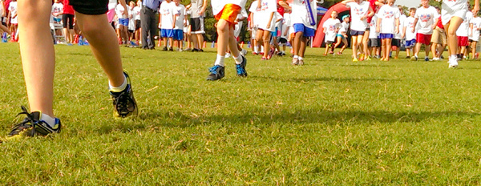

WELCOME BACK BBQ/A MESSAGE FROM PARENT COUNCIL

Hello John Fisher Parents!
I hope that your first couple of weeks of the new school year have gone well. I want to take this opportunity to do two things: first, to extend a huge thank you to our former vice-principal and the current principal of Brown Public School, Jessica Feldberg. Jessica was instrumental in making John Fisher the place that it is today - vibrant, happy and a place that we want to send our children. Although we will miss her, she will be an amazing principal. Our loss. Second, on behalf of all of the parents at John Fisher, I want to welcome our new vice-principal, Mme Maier. I have been lucky enough to have spent some time with Mme Maier and I can assure you all, that she is terrific. She and Mme Harroun are already an amazing team. I think we are going to have a great year.
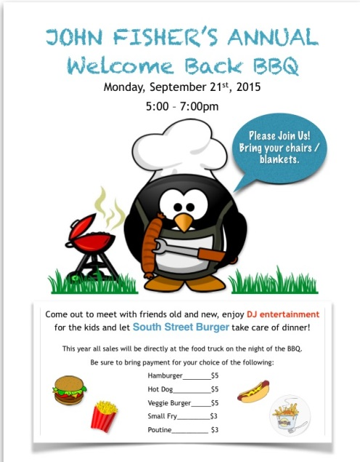
Do not forget about our Welcome Back Barbeque on Monday evening. This is a great event and our Welcoming and Recognition Committee - Tanya and Jodi - have been working hard to make it a fun evening. We look forward to seeing everyone! Bring your Toonies. Water and ice cream will be sold - proceeds towards school council funding of student initiatives. See you there!
Finally, please do not forget to fill in the Parent Directory and volunteer information. (See link below)
As always, do not hesitate to contact me with any questions,
Anne (accarty@yahoo.com)
Note: The John Fisher Welcome Back BBQ is an event organized by School Council as a way to connect with the John Fisher School Community and celebrate the start of a new school year.
This year, the BBQ will not be combined with curriculum night due to job action by members of the ETFO.
The Ontario Curriculum can be found online at http://www.edu.gov.on.ca/eng/curriculum/elementary/grades.html
Please contact your child’s teacher with any specific questions about communication and daily routines.

FAMILY DIRECTORY
Thanks to all of the families who have already submitted their contact information to our directory. We encourage all families to access our online form to submit your information to our family directory. This link will be accessible until midnight, Wednesday, September 23rd. More information about the directory, which includes a parent volunteer form, can be found at this link: http://tinyurl.com/jfdirectory.

AFTER FOUR WEBSITE/REGISTRATION
After Four registration forms can now be found on line. http://schoolweb.tdsb.on.ca/johnfisher/Parents/AfterFour.aspx

CLASS PARENTS
THANK YOU for the tremendous interest in volunteering as class parents this year! We had a great mix of experienced and new to the role parents step up, we are lucky to have such a great parent community!

In some cases, there were only two volunteers that came forward per class, and in others, there were more than two (up to 6!). Where there were more than two volunteers per class, Class Parents were selected on a lottery basis with preference to first time volunteers, in consultation with the teacher as well. If you didn't get an assignment, I hope you will continue to support your class and the school as there are many opportunities for involvement throughout the year.
I am still looking for 1-2 parents to come forward for M. Balsamo's class (grade 5) - if you are interested in taking on the class parent role, please let me know at mireille.landry@rogers.com

Thank you!

