JOSEPH BRANT NOVEMBER NEWSLETTER
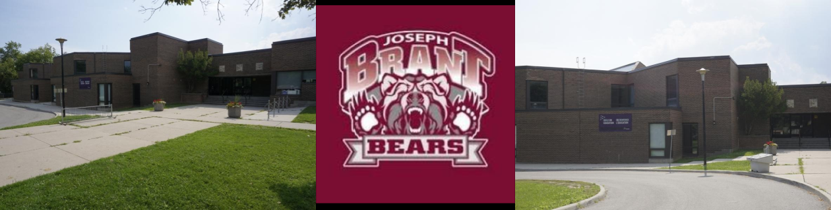
270 Manse Road, 416-396-6400 Principal: Christie Trialonis Vice Principal : Michael Ensor
School Website: https://schoolweb.tdsb.on.ca/josephbrant/
(please check our website often for updates and valued information)

November is the month of Empathy
Each month, the TDSB focuses on a character trait to exemplify and strive for. This month, the focus is on Empathy. Empathy is about showing understanding for other people’s feelings and imagining what someone else might be thinking or going through.

November is Indigenous Education Month
In November, we honour Indigenous Education Month at the Toronto District School Board. This month reminds us to centre First Nations, Métis and Inuit perspectives, voices, histories and contemporary realities. In classrooms across the TDSB, it is an opportunity to learn about treaties, Indigenous leadership, achievements, resistance and creativity.

November is Hindu Heritage Month
The Toronto District School Board (TDSB) is proud to recognize Hindu Heritage Month during the month of November as the Board of Trustees voted to pass a motion in April 2018 to mark this time. On December 8th, 2016, the Province of Ontario passed the Hindu Heritage Month Act by declaring that the month of November in each year is proclaimed as Hindu Heritage Month. Since the first Hindu immigrants arrived in Canada at the beginning of the 20th century, Hindu Canadians from across Ontario have made significant contributions across all fields: science, education, medicine, law, politics, business, culture and sports. Hindu Canadians have helped build Ontario into the multicultural success story that it is and have helped to build this province into the best place to live, work and raise families. They continue to help foster growth, prosperity and innovation throughout Ontario. Hinduism is one of the oldest living religions which have flourished for over 10,000 years. It is an occasion to recognize and celebrate the rich tapestry of traditions, teachings and values that are integral to Hinduism and practiced by millions around the world today. November is an opportunity to celebrate the Hindu way of life, examine its impact and contributions to the world culture, and recognize values which promote compassion, tolerance, and inclusion.

Daylight Savings Time
On Nov. 6th at 2:00 a.m., we set our time back one hour to save on daylight hours.

Progress Reports and Parent-Teacher Interviews
Parent Teacher Interviews: Nov. 17 4:00 to 8:00 pm
Nov. 18 P.A. Day for Parent -Teacher Interviews from 9:00 a.m. to 12:00 p.m.
Progress Reports go home on November 15th. Please reach out to your classroom teacher to book an appointment for an interview.
Regular parent-teacher communication is an important part of student learning. Parent-teacher interviews are scheduled throughout the year after report cards are sent home. [Insert school specific interview information].
These interviews are your opportunity to ask questions about your child's progress and to discuss any issues. In addition to regular scheduled parent-teacher interviews, you can request a meeting at any time during the school year by contacting the school or your child's teacher directly.
Parent Appreciation Breakfast
Date: Nov. 17, 2022 Time: 9:00 a.m. Location: Joseph Brant Staffroom
Parent(s)/Guardian(s)/Caregiver(s), please join us in our school staffroom, after dropping off your children in their line with their teachers. We wish to show our appreciation for all your flexibility and unwavering support during the most busy start to our school year. We celebrate your hard work to support your children through the transitions in our school and reassuring them of the positive long term outcomes. We will also introduce to you our School Community Worker, Donna Cardoza, as well as some of our literacy and numeracy specialist that have been assigned to work with students of our school. We will also have interpreters available to hear your voice and provide us with valued feedback on next steps you feel are needed to make our school a safe, beautiful and engaging environment.
Remembrance Day
This year, we will again commemorate Remembrance Day on November 11, beginning at 10:40 am. School community is welcome to join us at that time as we honour and reflect on those who gave their life for Freedom’s cause. Our focus will be on finding peaceful solutions to conflict so we may continue to build a peaceful school, peaceful neighbourhood, and in so doing spread peace wherever each of our journeys takes us.
Grade 8 Overnight Trip to Albion Hills
The Etobicoke Outdoor Education Centre is located on the Oak Ridges Moraine, in the Albion Hills Conservation Area. The program features geography and science-based programs focusing on the maple syrup sugar bush; sustainable agriculture; forest, wetland and pond ecosystems of the Humber River; and outdoor pursuits such as hiking, mountain biking and cross country skiing.
Information Night: Nov. 7, 2022 @ 6:30 p.m.
Zoom link: https://tdsb-ca.zoom.us/j/96058002429
Dates: Depart on Nov. 28 and return on Dec. 1st

Watch the video to learn more the Etobicoke Outdoor Education Centre in Albion Hills
About the Etobicoke Outdoor Education Centre.

Grade 8 to 9 Parent Information Nights and Open Houses
To support our Grade 8 students and families, the TDSB will be hosting a series of Preparing for High School Information Sessions. Students and families from any grade are welcome to attend. The series includes:
- The Grade 8 to Grade 9 Transition Information Session (November 1, 2022) will share the Top 10 Tips and Considerations in the Transition to High School and augments the work already taking place through secondary open houses and at Grade 8 schools.
- The Student Interest Programs Information Session (November 3, 2022) will help students and families learn more about local programs, Facilitated Access to Skilled Trades programs, out-of-area admissions and applying to centralized programs and schools, including:
Arts Focus Programs/Schools
CyberARTS Programs
Elite Athlete Programs
Exceptional Athlete Program
Integrated Technology School
International Baccalaureate Programs
Leadership Pathway Program
Math, Science & Technology Programs
Grade 8 to Grade 9 Transitions Information Session Flyer
Tuesday, November 1, 2022 at 7 p.m.
Link to register/ YouTube Link
Student Interest Programs Information Session Flyer
Thursday, November 3, 2022 at 7 p.m.
Link to Register / YouTube Link
3. The Virtual Secondary Alternative Schools Fair (November 9, 2022) will introduce families to the Alternative schools in the board that offer Grade 9 to 12 programming. Alternative schools are highly engaged, smaller school environments. They use non-traditional hands-on approaches to learning. Each school has a distinct identity and focus, such as democratic education, holistic learning, physical art, mindful living, entrepreneurship, social justice, community outreach and more. These schools are ideal for students seeking an alternative to mainstream education and who want to take an active role in their own learning.
Webinar Details
Teachers are encouraged to attend the webinar via the Parent & Community Engagement Office YouTube channel to learn more about
- Grade 8 to 9 transition
- Central Student Interest Programs
- Out-of-Area Admissions (former Optional Attendance)
- Alternative Schools with Grade 9 programs
Resources
Secondary School Virtual Open Houses and Information Sessions
www.tdsb.on.ca/OpenHouses
French Immersion
For families interested in the Toronto District School Board's French Immersion or Extended French programs, we offer an online process for applying to:
- Early French Immersion (EFI) which begins in Senior Kindergarten;
- Junior Extended French (JEF) which begins in Grade 4
At this time, we guarantee an offer of placement in the program (not a specific school) to all on-time applicants.

Early French Immersion (Junior Kindergarten (JK) Entry)

The entry point to Early French Immersion is Junior Kindergarten. It is an entirely online process. All communication will be sent via the email address you provide. Please check your email regularly, including junk mail folders.
To apply, please visit the application site www.tdsb.on.ca/pars.
IMPORTANT DATES:
Application process opens: October 31, 2022 Deadline for applications: November 25, 2022
Learn more at an Information Session!
For children born in 2019:
- Please select the “Non-TDSB Student” option and follow the steps to generate an identification number. You must then return to the PARS site and follow the application procedure with this number.
- Once in PARS, please select the Early Immersion Program from the drop-down menu, and complete the application process.
- On-time applicants will be offered a placement via the email address you have provided.
- You MUST take action to reserve a spot by the deadline requested when you are offered a placement

Wishing everyone a wonderful month,

Christie Trialonis, Principal, Joseph Brant P.S.

