Tasty Bugs
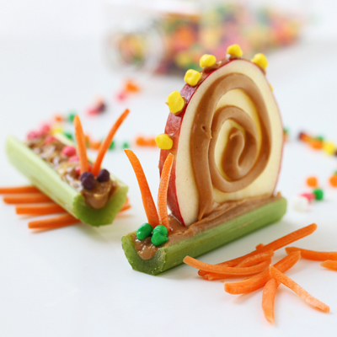
Math Strands: Number Sense and Numeration, Measurement
Grades: 1-2
Ingredients:
1 to 2 boxes of raisins or NERDS candies
1 red apple slice
1 stalk of celery
peanut butter or icing
shredded carrots
Instructions:
1. Take a stalk of celery.
2. Place 2 non-standard unit objects (e.g., paper clips, toothpicks, etc.) side by side, beside the celery stalk.
3. Cut celery at the end of the 2nd paperclip or toothpick.
4. Take a whole apple slice. Cut ½ of whole slice horizontally (across).
5. Put icing or peanut butter along length of stalk.
6. Make peanut butter or icing circle pattern on side of apple slice.
7. Place peanut butter or icing on top of apple slice.
8. Put apple stalk inside celery stalk.
9. Place 4-5 NERDS candies or raisins on top of apple slice.
10. Place 2 NERDS candies or raisins on one end of celery for eyes.
11. Place 2 pieces of shredded carrots on one end of celery stalk for antennae.
12. Eat.

