Grades 5-6
Manage Your Budget 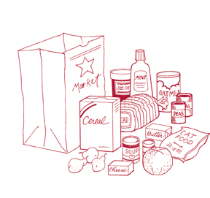
What you'll need
Flyers, Pencil, Calculator, Paper, Money
What to do
- Before going to the grocery store, read the flyer with your child. Have your child make a list of groceries they want to buy and estimate the total cost.
- Calculate the total cost of the grocery. Is your estimate reasonable?
- If your budget of the grocery shopping is $ 50, will you have enough money to buy all the items on your list? If you don’t, what could you do?
- Go to the grocery store and shop together. Buy the items listed on the shopping list. At the checkout counter, is the actual cost the same as your calculation? If not, read the receipt to find out the reason why.
- If you are going to pay by cash, how much change should you get back? If you are paying by credit card, how much will you actually pay if you miss the due date and the interest rate is 15%?

