TRAFFIC SAFETY AT LUCY MAUD MONTGOMERY PS
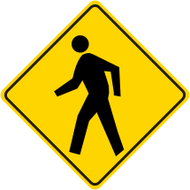
Leave the Car at Home
Walking is healthy and safer than driving. Moreover, parent-drivers may be inadvertently creating unsafe traffic conditions around the school. Therefore, parents are encouraged to walk their children to school to help reduce traffic congestion during entry and dismissal times.

Prepare for the Unexpected
It is difficult for children to see approaching traffic when they are attempting to cross the road between parked cars. Drivers should be cautious when driving near a school as children may enter the roadway suddenly. Respect the speed limits and be prepared for child pedestrians.

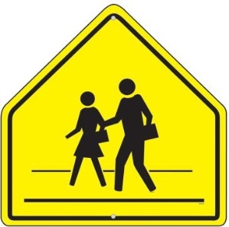
Teach Children to Safely Cross the Street and Escort Younger Children
Parents should teach children to look left, right, and left again and always make eye contact with drivers of approaching vehicles before crossing the road and to always use the crosswalk. Pedestrians should continue watching for traffic as they cross the road. Children must learn to not to assume that all drivers will stop. An adult should escort younger children across the street using the crosswalk.

Avoid Our Lucy Maud “Rush Hour”
If you must drive children to school, try to avoid arriving at the 8:40 AM entry time or at 3:05 PM dismissal. School yard supervision is provided before school from 8:30 AM and after school until 3:20 PM. By arriving a few minutes early or late, motorists will avoid the most congested few minutes and children will be supervised by school staff.

Avoid the School Parking Lot
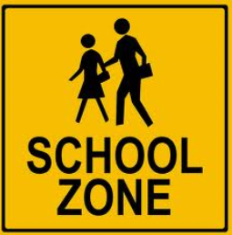
Unfortunately we do not have a pick-up and drop off lane and the parking lot has one driveway for entrance and exit. Please refrain from using our parking lot from 8:30 to 9:30 AM, from 11:00 AM to 1:00 PM and from 2:30 to 3:30 PM. The concern is that cars accessing our parking lot must cross over the sidewalk used by children walking to school. We are also concerned about children entering and leaving vehicles in a congested overcrowded lot. Fewer cars in school parking lots reduces conflicts between pedestrians and vehicle traffic.

Remember Traffic Safety Regulations
The Toronto Police Service is responsible for traffic enforcement outside the school. The real penalty for not obeying school zone traffic regulations is that the safety of children could be jeopardized. It is important that motorists obey traffic safety regulations.

No U-Turns and No Backing-Up: Drivers should not make “U-Turns” or reverse their vehicle in a school zone. It is difficult for drivers who are making a “U-Turn” or “backing-up” to see small children crossing the street. “U-Turns” can be confusing for children as they may not be able to anticipate such vehicular movements.

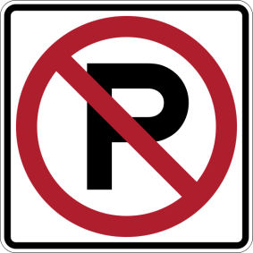
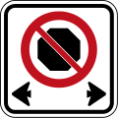
NO STOPPING ZONE: These are areas where a stopped vehicle could obstruct the visibility of other drivers and pedestrians and increase the likelihood of a collision.

No PARKING ZONE: You may stop briefly to drop off or pick up a passenger, but you cannot wait in your vehicle or leave your vehicle unattended.
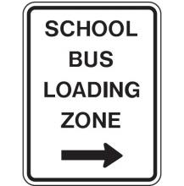
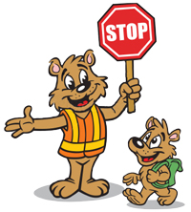
SCHOOL BUSSES: Motorists approaching a stopped school bus with its overhead alternating red signal lights flashing must stop at least 20 metres before reaching the bus. Motorists may not proceed until the bus begins moving or the red signal lights have stopped flashing.

SCHOOL AREA SIGNS: Slow down, drive with extra caution and watch for children.

SCHOOL CROSSSING Guard: Watch for children and follow the directions of the Crossing Guard.

PEDESTRIAN AHEAD SIGNS: This sign is a warning that pedestrians may be in the area.

