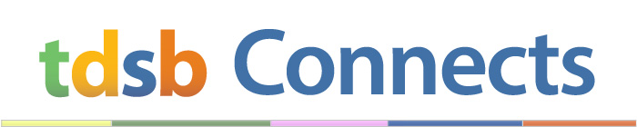

April 2019
Parent/Guardian
Welcome to TDSB Connects, an update on news and events from across the Toronto District School Board.
- Updates on Public Education Funding, Teacher Reductions: Recently, the Ministry of Education announced upcoming changes to class sizes for Grades 4 to 8 and high schools, and reductions in funding for public education. To keep you well informed, we have created a webpage that will be updated as more information becomes available.
- Ministry’s Consultation – Class Sizes and Hiring Practices: Parents, students, educators and community members are encouraged to participate in the Ministry of Education’s consultation on class sizes and hiring practices. To learn more, including how to participate, please read the consultation guides. Deadline: May 31, 2019.
- Excellence Awards: Do you know a TDSB staff member who goes above and beyond to support our students? Now is the time to honour that outstanding individual with an Excellence Award Nomination. Deadline is April 26, 2019.
- Policy Consultations: The TDSB is currently looking for public input on the Caring and Safe Schools Policy (P051). To learn more, including how you can participate, please visit the TDSB webpage for Policy Consultations. Your input is welcomed and appreciated.
- Earth Day: On April 22, #FreeYourPlay by encouraging children to get out, connect with the environment and experience the natural world around them. For resources and to learn more about Earth Day, please visit the website for Earth Day Canada.
- Celebrate and Recognize: In April, the TDSB recognizes Sikh Heritage Month, Hispanic Heritage Month and Latin-America History Month. Learn more about how we’re celebrating!
- TDSB Update: Sign-up for TDSB Update and stay informed about recent Board decisions and district-wide news.

