 Strive Share Soar

The Trailblazer Monthly Newsletter

April 2019

***Message from the Administration***

‘Happy Spring’ to our amazing Military Trail community!! Our new school website is up and running and is a wealth of information! Several areas of TDSB information from Kindergarten registration, to school procedures are now included. New to our website is a Translate button at the top right corner of our Home Page that will convert all text to the language of choice. We have also included a quick link to The Weather Network for our school in particular which will also provide suggestions for appropriate clothing for the day’s forecast. We have provided information regarding extra programs that our school is offering in cooperation with other organizations (i.e., Toronto Public Health and University of Toronto). Our Web site can be found: <https://schoolweb.tdsb.on.ca/militarytrail/> Please check it out and let us know your thoughts.

We are now almost half way through term two. This offers a great opportunity for parents to discuss future goals with their children and make a plan to attain goals before the end of the school year. By establishing these goals, our students can have a focus to achieve something that they can take great pride in.

**Event Alert!!!!!**

On April 29th, 2019, Military Trail will be hosting its very first ***Mental Health and Wellness Night***. It will begin at 5:00pm and run through to 7:30pm. There will be Zumba, Yoga, Nutrition workshops, Mindfulness activities and refreshments and prizes. Please see the ***#MTM Military Trail Matters*** posters in this newsletter and on our school website. We look forward to seeing you all there!

Mr. Shaikh (Principal) and Mr. Lalonde (Vice Principal)Upcoming Dates in April:

**Weekly Activities**

Monday:

Boys and Girls Club Mentoring Program @ 11:30am

Playground PALs @ AM recess

Tuesday:

Choir Practice @ 11:30am

Wednesday:

Playground PALs @ AM recess

Thursday:

Me to We @ 11:30am

SEEDS program Gr.5-7

Friday:

Playground PALs @ AM recess

April ***– Hispanic Heritage Month***

***Latin-America History Month***

April 5th – LEAP Program Reviews

April 16th – Water Docs Film Appreciation Day

April 17th – Student/Teacher Basketball Fundraiser

April 18th – Track and Field Tryouts

April 19th – Good Friday – No School

April 22nd – Easter Monday – No School

April 24th – ‘Military Trail Talks’ Speech Arts Competition

April 26th – Jump Rope for Heart Kick off Assembly

April 29th – Mental Health and Wellness Night

Student Voices

Grade 1 Science Trip

On Wednesday, March 6th, the Grade 1 class went to the Ontario Science Centre. First, we went to the rainforest exhibit. Then, we went to the science arcade. Also, the boy in the exhibit sneezed in our faces! Lastly, my Dad came too. We had a science teacher named Ms. Heidi. We saw bugs, silly mirrors and a cave! That’s some of the things we saw. We went to the Kids Park after lunch too! Me and my Dad felt great on our first trip! It was the best trip I ever had!

Written by **Tasneem M**. in Mrs. Hestick’s Grade 1 class

On Wednesday, March 6th, the Grade 1 class went to the Ontario Science Centre . First, we played with the big giant house. Next, we went to the rainforest and it was so hot in the rainforest. Third, we went to the Kids Park. Last, I felt so glad and it was my best trip.

Written by **Taleen A**. in Mrs. Hestick’s Grade 1 class

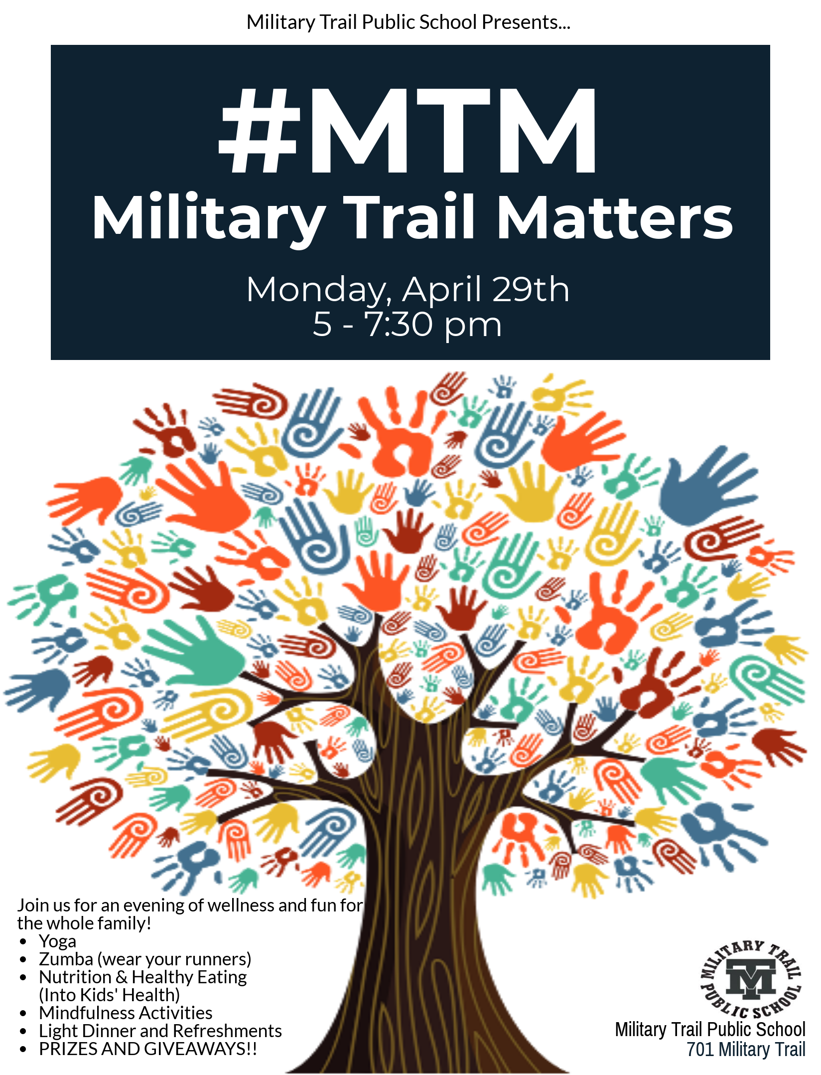

SEWING CLUB

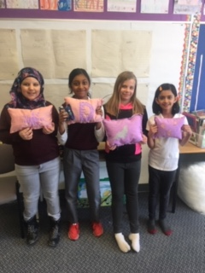Sewing club has been meeting once a week since October. Students in Grade's 4, 5 and 6 joined the club and worked on two sewing projects. Using a variety of fabrics, the participants showed great patience and perseverance as they hand cut and sewed pin cushions and toss pillows. Congratulations to all the participants who are now able to take their projects home to enjoy! We hope they have come away with some skills that they can use in the future. **Ms. Giza and Ms. Emerson**

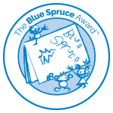**Forest of Reading programs are underway at Military Trail!**  
  
The Forest of Reading® is Canada's largest recreational reading program! This province-wide initiative offers several reading programs to encourage a love of reading in people of all ages. The Forest helps celebrate Canadian books, publishers, authors and illustrators.

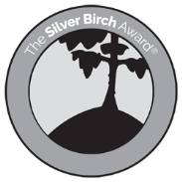Blue Spruce is an exciting reading program that brings recently published Canadian children's picture books to students in kindergarten through to grade two.  This program promotes reading for enjoyment and begins to develop the reader’s skill in evaluating a picture book based on story, text and pictures. Teachers read aloud a nominated selection of 10 picture books to their class.  Students have the opportunity to discuss these picture books in an authentic manner, and literacy activities to complement each book will also be provided.  Once all 10 books have been read, students vote for their favourite story.  The book that gets the most votes province-wide wins the Blue Spruce Award!

Our grades 3-8 students have had the opportunity to sign up for the Silver Birch and Red Maple Reading Clubs since January of this year. These reading clubs are extra-curricular and members meet on Fridays at lunch.  The programs’ aim to get readers engaging in conversation around the books and encourages them to use critical thinking while reading.  There are a total of five different lists of 10 nominated books, comprised of both fiction and non-fiction titles.  Readers need to read at least 5 out of 10 nominated titles to be eligible to vote for their favourite, and all readers who successfully qualify to vote for an award are invited to attend the Festival of Trees Celebration at Harbourfront Centre in May.

All Forest of Reading programs are coordinated through the school library.  For more information about Blue Spruce, Silver Birch or Red Maple, please contact Mrs. Davidson or visit this website - <http://bit.ly/forestofreading2019>

**Month – Honesty**

**The following students received this month’s Character Trait of the Month Certificate for Honesty.**

**The character trait for the month of April is Co-operation.**

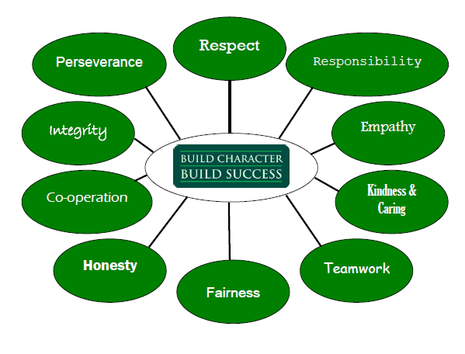

JSK – Ms. McGimpsey: Noura Bafakih, Zoe White

JSK Ms. Burton: Joel Cesar, Leeya Chintaman

JSK – Ms. Figueroa: Anas Alnofa, Journey Francis

Gr.1 – Ms. Majchrzak: Yusof Attia, Zavon Tyrill

Gr.1 – Ms. Hestick: Daniel-Jayden Johnson, Kenan Marei

Gr. ½ - Ms. Jacob: Stephanie Ekvase

Gr.2 – Ms. Theiv: Mohid Taeseen, Ibrahim Hassan

Gr.2/3 – Ms. Ghabour: Isiah Markland, Haniya Khan

Gr.3 – Ms. Maricar: Carl Murdock-Burke, King Polgar

Gr.3 – Mr. Herbert: Sai Shriyesh Ramanathan, Theshan Ninthakaran

Gr.3/4 – Mr. Murphy: Muhammad Nasreddeen, King Palmer

Primary ESL – Ms. George Alexander: Taghrid Alnofal, Hanan Alnofal

Gr.4 – Ms. Storrod: Ishitha Neelakantan, Nimra Tanvir

Gr.4/5 – Ms. Giza: Rabia Noor, Neeraj Chandran

Gr.5 – Mr. Deslandes: Fatima Khalil, Tishanique Scott

Gr.5/6 – Ms. McGroarty: Umar Khan, Nabiha Noor

Gr.5/6 – Mr. Sharma: Khyra Baptiste, Sharujan Thiruvarudselvan

Gr.6 – Ms. Nelson/Mr.Johnson: Ahmad Hajji, Zaynab Sherif

Gr.7 – Ms. Jackman: Nayanan Premkumar, Lagshan Kirupakaran

Gr.7/8 – Mr. Gad: Katie Barrow, Michael Ho-Sue

Gr.8 Mr. Johnston: Breanna Kathirgamanathan, Majed Al-Aslan

Jr. HSP Ms. Pellet: Dominic Williams-Peters, Tharangan Jeyakumar Int. HSP Mr. Johnson: Sade Bennett

ESL – Ms. Luther: LEAP Ms. Khan: Sedra K. Al-Hamade, Ahmad Hassan

French – Ms. Nelson: Jonathan McIntyre

