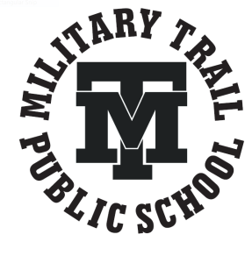
Strive Share Soar

The Trailblazer Monthly Newsletter
December 2019

Message from the Administration
The Holiday Break is fast approaching, and the month of December will fly by very quickly! Just a reminder to our parents and guardians that the last day of school before the Holiday Break is Friday December 20th and students return to school on Monday January 6th, 2020.
It is with great excitement that we announce the date and time for Military Trail’s 50th Anniversary Celebration. Join us for a very special day of strolling through memory lane in celebration of Military Trail’s 50th Anniversary! On May 2, 2020, our school will be opening its doors to welcome current and former staff, students, alumni and community members. To mark the occasion, we will have displays showcasing the evolution of our vibrant school community through the decades. Although this statement is often made, it is deeply meaningful to our school--at Military Trail, we live and thrive with the knowledge that our diversity is truly our greatest strength. We hope you will join us to mark 50 years of serving this remarkable community.
For updated information, please visit or School website https://schoolweb.tdsb.on.ca/militarytrail/ or our Twitter @MilitaryTrailPS and special 50th Anniversary Facebook page.
The month of December also reminds us that our winter holidays are fast approaching along with our Annual Winter Concert which will be held on Wednesday, December 18th, 2019. This year’s theme is ‘Rockin’ the Holidays.’ Please mark your calendars for a fabulous night of entertainment.
For greater communication, we continue to collect parent email addresses to provide you with the monthly newsletter and any important information from the school. Our goal is to be completely paperless when delivering our monthly newsletter. If we do not have a current email address, please provide it to the office to ensure you get all of our school’s communications.
We both would like to wish you a safe and happy holiday and that you can welcome the New Year with family and friends.
Wishing you all the best for a great end to 2019, and superb start to 2020!

Mr. Shaikh (Principal) and Mr. Lalonde (Vice Principal)
Upcoming Dates in December:
Weekly Activities
Monday:
Intramural Houseleague Play @ Lunch
Go Girls Group @ Lunch
Tuesday:
Boys’ and Girls’ Club Mentorship Program @ Lunch
Wednesday:
Intramural Houseleague Play @ Lunch
Thursday:
Intramural Houseleague Play@ Lunch
Me to We Club Meetings
Friday:
Girls’ Basketball through OBA @ Lunch
December 5th – Youth Trails Application Deadline
December 6th – PA Day – No school for students
December 17th – Santa’s Shop
December 18th – Winter Concert
December 23rd –January 3rd – Winter Break

Student Voices
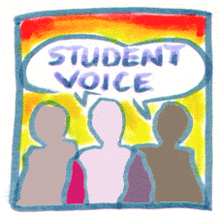
Student Voices is a platform where students can voice their opinions and showcase their work.

Cinquain Poems from Mr. Phillip’s Class
Leaves by Adarsh Leena
Found leaves
Time to crunch them
As they became small pieces
As I found more colourful leaves
Looks good
Warm Feeling by Hajrah Saleem

The sun
Hits your face
It’s warm and hot on the inside
You feel kind of comfort
It’s nice
Anti Cyberbullying – Grade 6 students in Ms. Nelson’s class
The Grade 6 students in room 207 have been starting to focus on their own health from a different perspective. With the prevalence of social media and other digital forums it is important that students are aware of the realities that exist, how to protect themselves and how to utilize such platforms in a positive way. As an introduction, the grade 6 students have been focusing on CYBERBULLYING and what it is, how to prevent it, and steps to take if ever faced with an uncomfortable scenario. With some media and literacy research the students were able to create “ANTI-CYBERBULLYING” posters. On these posters they included some very helpful advice for anyone facing cyberbullying. Some of the tips were as follows:
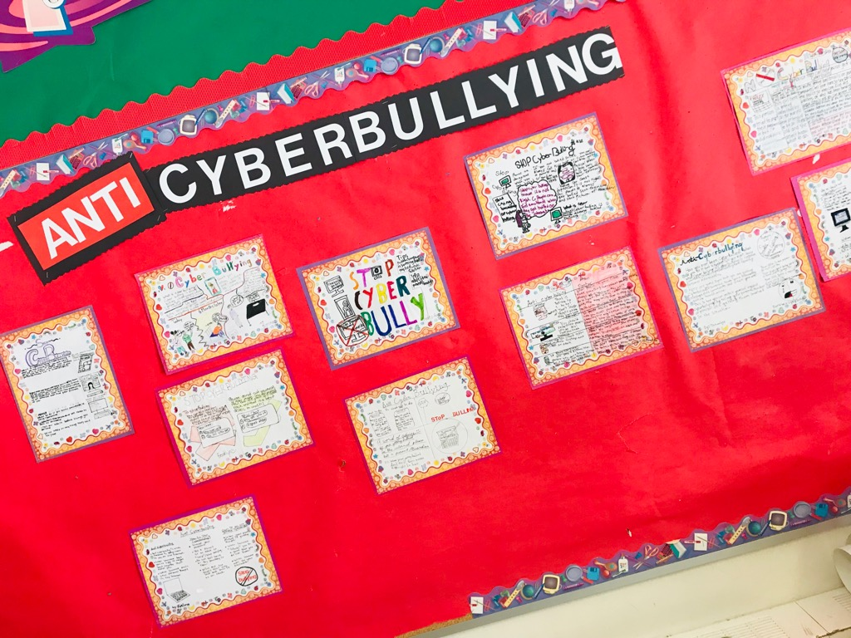• Tell a parent/adult to help
• Protect/Change passwords
• DO NOT respond
• DO NOT give anyone online any personal information
• DO NOT post or send pictures
With great interest we will continue to explore this topic and all the realities that follow it in order for students to feel safe and accepted in all areas of their own personal health.
-Mrs. Nelson
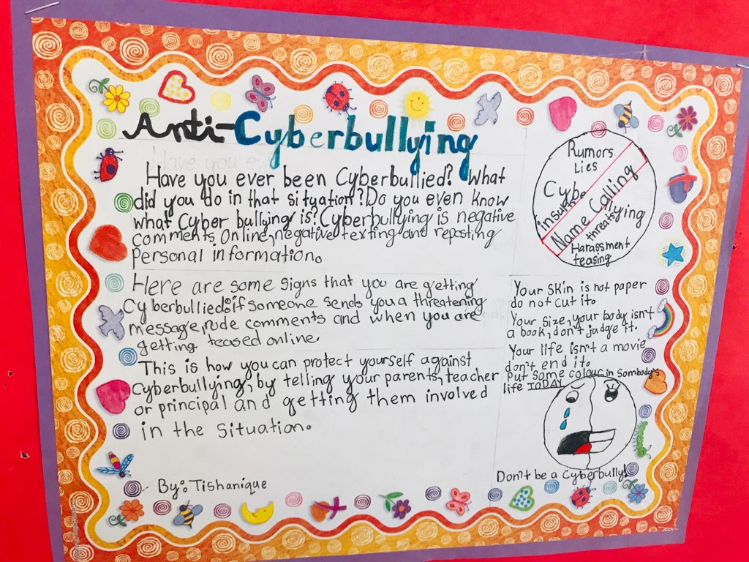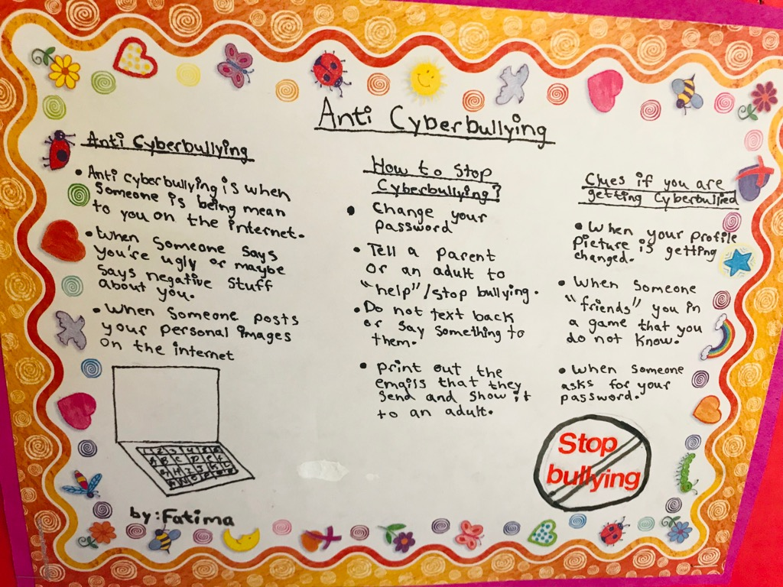

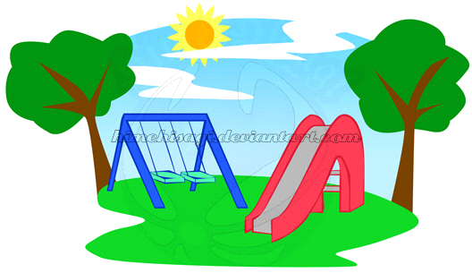
Collaborative Inquiry Project - Grade 1’s and Grade 8’s

In Grade One, we have been exploring a wide variety of common materials, objects, and everyday structures. Some important concepts we have been focusing on are as follows:

- objects have observable characteristics and are made from materials
- materials have specific properties
- an object is held together by its structure
- the materials and structures of an object determine its purpose
- humans make choices related to their use of objects and materials that have a direct effect on the environment
We have started our Playground Structure Inquiry with the help of our grade 8 Reading Buddies. Our students took a trip to our very own school playground and then to Brooks Road Park to investigate answers to some of our wonderments and questions regarding structures. We have started to design and plan our own playground structures and will begin to create a model using recycled materials. This is a hands-on and engaging unit. If you are able to send any recyclable objects or bits and pieces you may already have around your house, it would be greatly appreciated! Here are a few suggestions of items we might need:

-popsicle sticks -masking tape -tin foil
-glue -plastic wrap -newspapers
-paper towel tubes -small boxes -small containers
-cotton balls -tissue paper -toothpicks
-sponges -foam pieces -elastics
-water bottle caps -string/ribbon

Thank you to all the parents, teachers, and students who are supporting the learning of our friends in Grade One.

The Grade One Team (Ms Madej and Ms Hestick)

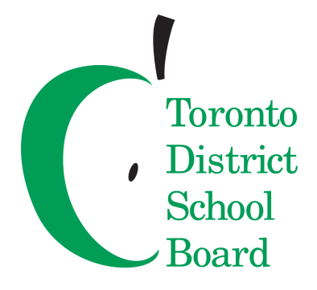
Secondary Program Review and Optional Attendance

The Toronto District School Board (TDSB) is undertaking a review of secondary schools to ensure all students have equitable access to programs and opportunities, as close to home as possible. As part of the Secondary Program Review, the TDSB is reviewing the Optional Attendance policy (P013), which allows students to apply to schools other than their designated school by home address.
A public consultation process for both the Secondary Review and P013 started in November 2019. Please visit the TDSB website for more information and opportunities to provide feedback: https://www.tdsb.on.ca/High-School/Secondary-Program-Review.
If you have any questions and/or comments, please email SecondaryReview@tdsb.on.ca
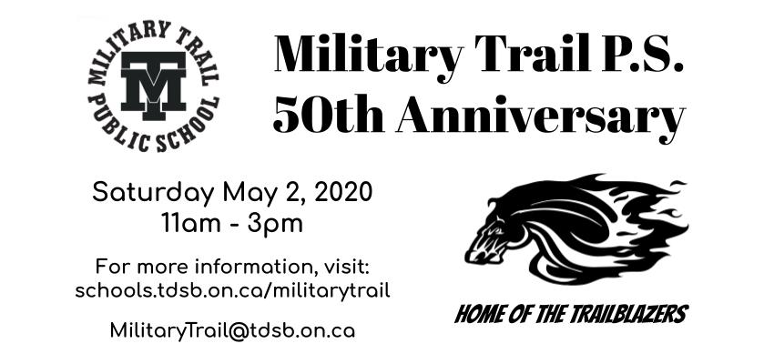
Character Traits of the Month - Empathy
The following students received this month’s Character Trait of the Month Certificate for Empathy.
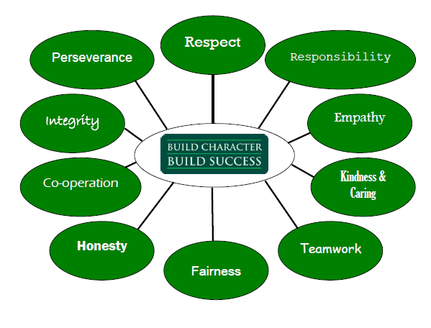
Kindergarten/ Primary Classes
Mrs. Moxam: Vajra Totapalli, Aaliyah Osman
Mrs. Burton:
Mrs. Figueroa: Assil Faraj Hamdi
Mrs. Madej: Grace James, Anthony Ishmael
Mrs. Hestick: Tayla Bradshaw-Hunt Emma Resaul
Mrs. Jacob: Ranim Al Zoubi , Faith Koleola
Mrs. Maricar: Oumou Bah, Teriyah Atkins-Baird
Mrs. Dickie: Carter Henry , Brooklyn Cormier-Hamm
Mrs. Khandaker: Divine Nyamali, Aliyah Sinclair
Mr. Murphy:
Ms. Thompson: Armaghan Sadat (pri), Batoul Alwadi (jr)
Ms. Alidina: Ranim Al Zoubi, Mohamad Al Aslan
Ms. Bandon: Muayyad Al koud, Banan Najib

Junior Intermediate
Mrs. Storrod: Yasmine Hajji, Mujtaba Ahmed
Ms. Giza: Victoria Kim, Vishwa Jayasekara
Mr. Deslandes: Sharujan Thiruvarudselvan, Arya Pavithran
Mr. Sharma: Arnav Gupta, Molik Arrundell
Ms. Luther: Kishan Niranchan, Tishanique Scott
Mr. Johnson/ Ms. Nelson: Olivia Maxwell, Natalya Brown
Mr. Phillips: Adarsh Leena, Hajrah Saleem
Ms. Pellett: Amira De Abreu
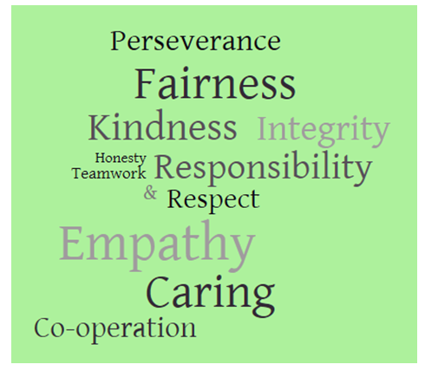
Ms. Khan:
Ms. Jackman:
Mr. Gad: Hagar Nasreddeen, Ashwin Anuraj
Mr. Johnston: Joshua Rajanthan, Raqiya Duale
Mr. Johnson:
Ms. Nelson’s French Class: Vegra Kirupananthan
Ms. Thineskumar: Victoria Kim
Mr. Deslandes (ESL): Abdulrahman Tabl

