Strive Share Soar

The Trailblazer Monthly Newsletter
February 2020

Message from the Administration
As our year continues to move forward, amazing things are happening in our classrooms. Our teachers continue to offer our students wonderful learning opportunities throughout the school. Our grade 6 students were recently presented with a wonderful gift of a copy of the book “Hana’s Suitcase”, a depiction of a young girl’s experience through the Holocaust. Their teachers are utilizing this opportunity to teach our students the importance of respecting all people of all races and religions and to erase hatred and racism in the world. While acknowledging the 75th Liberation of the Concentration Camps at the end of the Second World War, our students were given the experience to relive the lives of Hana and her family through a board-wide webinar that featured a member of Hana’s family who brought the book to life.
We would like to thank Ward 19 Trustee Zakir Patel for hosting his Ward Forum at Military Trail on January 30th, 2020. We also thank Sheryl Robinson Petrazzini and our other administrators from our area for attending the evening and especially those parents who attended. We are hoping that this evening was enlightening and informative for all our Ward 19 communities.
As we move into February, we would like to wish everyone a Happy Family Day and hope that you take the opportunity to enjoy time with family and friends. Please be reminded, that February 14th marks an opportunity for parents to contact their children’s teachers to set up an interview/phone call to discuss the progress of their child, as long as it falls within the reduced workday as per ETFO’s sanctions (30 minutes before the start of the instructional day and 15 minutes after the end of the instructional day).
Should you require any information regarding the current labour updates or the Coronaviris, please refer to the Toronto District School Board website www.tdsb.on.ca for regular updates.

Mr. Shaikh (Principal) and Mr. Lalonde (Vice Principal)
Upcoming Dates in February:
Weekly Activities
Activities are postponed until further notice
Monday:
Intrmural Houseleague Play @ Lunch
Go Girls Group @ Lunch
Tuesday:
Boys’ and Girls’ Club Mentorship Program @ Lunch
Wednesday:
Intramural Houseleague Play @ Lunch
Thursday:
Intramural Houseleague Play@ Lunch
Friday:
Girls’ Basketball through Lay Up Program @ Lunch
February 5th – Constable Rowe and Gill Safety Presentations with Grade 2 and 8 classes
February 13th – Student Dress Down
February 13th – Intermediate dance in the afternoon
February 14th – Parent/Teacher Interviews
February 14th – Valentine’s Day
February 18th – Family Day
February 20th –Grad Photos

Secondary Program Review and Optional Attendance

The Toronto District School Board (TDSB) is undertaking a review of secondary schools to ensure all students have equitable access to programs and opportunities, as close to home as possible. As part of the Secondary Program Review, the TDSB is reviewing the Optional Attendance policy (P013), which allows students to apply to schools other than their designated school by home address.
A public consultation process for both the Secondary Review and P013 started in November 2019. Please visit the TDSB website for more information and opportunities to provide feedback: https://www.tdsb.on.ca/High-School/Secondary-Program-Review.
If you have any questions and/or comments, please email SecondaryReview@tdsb.on.ca

Character Traits of the Month:
Teamwork
The following students received this month’s Character Trait of the Month Certificate for Teamwork.
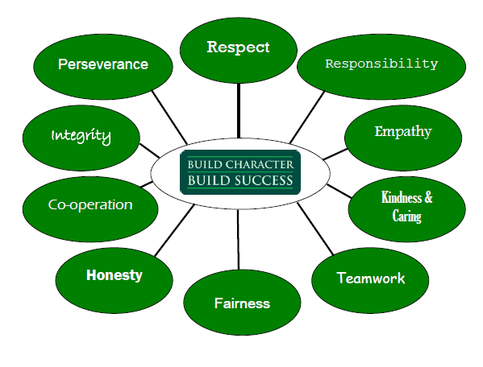
Kindergarten/ Primary Classes
Mrs. Moxam: Usman Taaseen, Kulthum Arghoshi
Mrs. Burton: Taric Blackette
Mrs. Figueroa: Manusri Jeyakumar
Mrs. Madej: Aisha Jegarooban, Laith Al Mohammad
Mrs. Hestick: Omari Manley-Jack, Aeesha Kadiri
Mrs. Jacob: Varnan Jeyabalan, Farouq Fedlu
Mrs. Maricar: Zavon Tyrill, Saieshan Thiruvarudselvan
Mrs. Dickie: Namesius Nagendra, Avilon Bhatta
Mrs. Khandaker: Mahrus Tawsif, Aryan Lachman
Mr. Murphy: Urhum Qadir, Alex Chintaman
Ms. Thompson: Lilaf Bilal (pri), Blessing Adesotu (jr)
Ms. Alidina:
Ms. Brandon: Tawfiq Ahmadi, Maria Alefragkis

Junior Intermediate
Mrs. Storrod: Carl Murdock, Shambavie Thiruvarudselvan
Ms. Giza: Hassan Jimoh-Kuku, Suruthy Sanjeevkumar
Mr. Deslandes: Farazinn Baksha, Benjamin Nesan
Mr. Sharma: Kyron Bailey-Shallow, Rabia Noor
Ms. Luther: Joyce Koleola, Destiny Ehidiamen
Mr. Johnson/ Ms. Nelson: Diyar Ali, Sarah Hailu
Mr. Phillips: Umeshi Arulnithy, Kerlon Bailey-Shallow
Ms. Pellett: Hussain Abbas, De’Andre Augustin-Browne
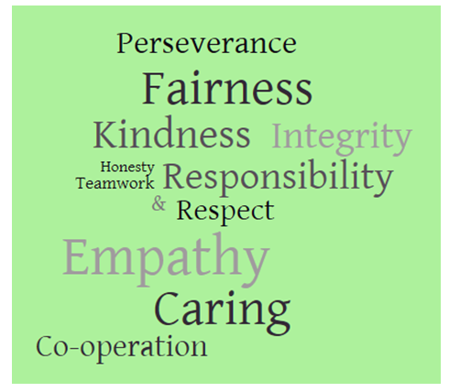
Ms. Khan: Maram Al-Mohammad, Banan Najib
Ms. Jackman: Laily Quaderi, Jack Sanmugananthan
Mr. Gad: Adrien Rooplal, Ashwin Anuraj
Mr. Johnston: Abdullah Argoshi, Mishal Mansoor
Mr. Johnson:
Ms. Nelson’s French Class: Katie Barrow
Ms. Thineskumar: Alexander Chintaman
Mr. Deslandes (ESL): Abdulrahman Megahed

Making the Best of Winter Weather at our School
Principals are often asked how we decide whether it's too cold to allow our students out in the schoolyard for recess.
Fresh air and exercise are important for children. It keeps them physically fit, and helps them stay alert all through the school day. Parents can help by making sure their children come to school prepared to spend time outdoors. Hats, mitts, boots and a warm jacket are important to keep students comfortable during lunch and recess.
But extreme cold can be dangerous, and parents want to know that their children will be safe. When the temperature is predicted to drop below -15C, the City of Toronto may declare a cold weather alert. Schools are very sensitive to the needs of our students and pay close attention to the weather, especially when the windchill is below -20 C.
The TDSB Severe Weather Protocol is flexible, so that every principal can make a decision that meets the needs of his or her school. It sets guidelines for when to allow students outside for recess, when to make outdoor breaks shorter, and when to keep students inside altogether.
Canadian winters can be wonderful but when the weather is cold, school staff keep one eye on the thermometer and the other on the needs of our students - a perfect balance of fun and safety.
Kindergarten Registration
Registration for all TDSB Kindergarten programs begins in February. We look forward to welcoming you and your child at our school in September!
To attend Junior Kindergarten in September, children must turn four-years-old by December 31. To register for Senior Kindergarten, children must be five-years-old by December 31. You may choose to register in person at the school or begin the process online.
For more information about the Kindergarten program and registration requirements, please visit www.tdsb.on.ca/kindergarten.

