Strive Share Soar

The Trailblazer
Monthly Newsletter
May 2019

Message from the Administration
It has been a wonderful month of April with many exciting events. We enjoyed our Mental Health and Wellness Night (#MTM) which was organized by Ms. Hestick and her Wellness committee. It was so great to see our parents and students engaged in the various activities offered throughout the evening. We would like to thank Ms. Robinson-Petrazzini our Superintendent of Education and Mr. Patel, our area Trustee for attending. Our students also participated in the Military Trail Talks Speech Arts competition where students from the Junior and Intermediate grades competed to represent Military Trail at the TDSB Talks event on May 1st, 2019. Our spring sports have begun with the addition of the Blue Jays Care Foundation who, with the help of the Blue Jays, Military Trail will have a Co-ed baseball team that will play a variety of teams throughout the city. We thank the Toronto Blue Jay organization for helping train and coach our students. Other sports on the horizon, include Track and Field, Ultimate, Cricket and Flag Rugby. Our dedicated staff, volunteer their time to work with our students to bring these opportunities and we would love to see the support from the community when we play our games.
The month of May is shaping up to be as busy as April. We will be having an Asian Heritage assembly on the 15th, our Jump Rope for Heart event on the 17th and our EQAO testing will begin on the 21st. New events crop up regularly, so please refer to the school calendar on our website. We continue to wish for warm weather and we hope to see all of you out at our various events for the month.
Mr. Shaikh (Principal) and Mr. Lalonde (Vice Principal)
Upcoming Dates in May:
May –
Weekly Activities
Monday:
Boys and Girls Club Mentoring Program @ 11:30am
Playground PALs @ AM recess
Tuesday:
Choir Practice @ 11:30am
Wednesday:
Playground PALs @ AM recess
Thursday:
Me to We @ 11:30am
Friday:
Playground PALs @ AM recess
May 1st – TDSB Talks Speech Arts Competition
May 3rd – Student vs. Teacher Basketball Fundraiser
May 8th – Grade 7 and 8 Student Vaccinations
May 10th – Track and Field East Qualifying Meet @ Birchmount
May 12th – Mothers’ Day
May15th – Asian Heritage Assembly
May 17th – Jump Rope for Heart Event
May 20th – Victoria Day- No School
May 21st – June 3rd – EQAO Testing for Grade 3 and 6 students
May 23rd – East Cricket Qualifying tournament
May 29th – Bicycle Safety Presentations

Student Voices
TDSB Talks – Speech Arts competition
Presenting at speech arts was nerve wracking. Having to speak in front of an audience is definitely a beneficial yet frightening experience. It’s difficult to see that everyone is watching your every move, trying to pick out the mistakes you make but once I got up there and started talking, it felt natural. It’s an amazing experience and will help me be confident talking in front of any audience. Hearing my name being called for the winning speech was unexpected and thrilling but I could not be more happy. Thank you to all the teachers and peers that assisted me in preparing my speech. I received many tips and pointers that made my presentation as perfect as it could, without which I would not have succeeded.
Breanna Kathirgamanathan – Grade 8
We are all very proud of Breanna and the rest of our Military Trail Speech Arts Contestants. They represented our school with dignity, class and we are very proud of them.
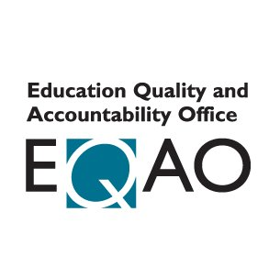
EQAO – Provincial Standardized Testing
EQAO Standardized testing will be administered to the Grade 3 and 6 students starting the week of May 21st and continues for those following two weeks. This test focuses on the areas of Reading, Writing and Math. Ms. Alexander is currently providing an opportunity for students and their parents to attend weekly sessions to understand and work through some sample questions to help students prepare for the test. The EQAO after school family sessions, on Thursdays from 3:30-4:00 pm, will be continuing until Thursday May 16, in room 113 (Adult ESL room).

WaterDocs @ School Action Projects
8A Runners Up for Best Project

This year Grade 8 science students participated in a documentary film making project with the goal of raising awareness about a water issue in their neighbourhood. The groups devised projects around trusting tap water, walking more often, and taking shorter showers. One group received an honourable mention at the Film Festival for their project about eating less meat. In addition to learning all about how our water systems work students felt the opportunity to create their own documentary film was great for learning how to film, edit and capture sound. Congratulations to MeatNoMore for being recognized at the festival.

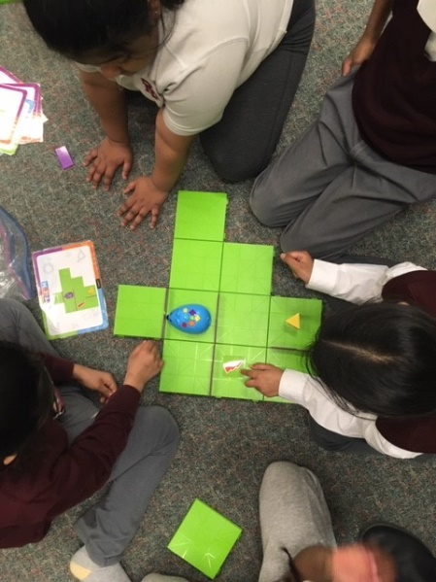
RoboGirls
Our Robogirls have been developing their coding skills during the past few weeks. They are gaining confidence programming robots and learning that communication skills are the key to success. We are excited to see what the girls will do in the final weeks!

Month – Cooperation
The following students received this month’s Character Trait of the Month Certificate for Cooperation.
The character trait for the month of May is Integrity.

JSK – Ms. McGimpsey: Aaliyah Osman, Saran Sanjithan
JSK Ms. Burton: Safiyya Karim, Avinas Kavithasan
JSK – Ms. Figueroa: Mohamad Al Aslan, Muhammad Khan
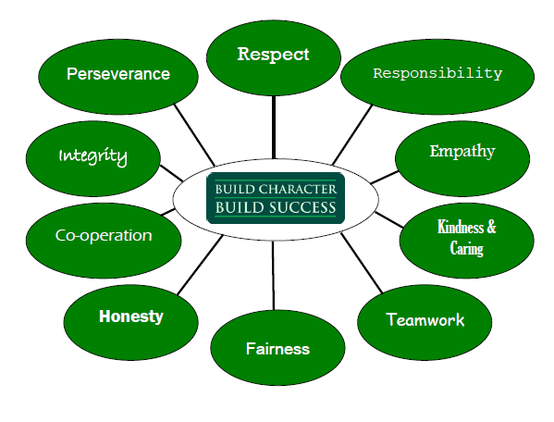
Gr.1 – Ms. Majchrzak: Saieshan Thiruvarudselvan, Isabella Rodriguez
Gr.1 – Ms. Hestick: Dima Ali, Taleen Al Khateeb
Gr. ½ - Ms. Jacob: Davina Edohen, Lekha Subramanyam
Gr.2 – Ms. Theiv: Abigail Gutierrez, Idosia Larmond
Gr.2/3 – Ms. Ghabour: Elianna Levermore, Lilaf Bilal
Gr.3 – Ms. Maricar: Sawban Chowdhury, Kaemonia Bailey-Shallow
Gr.3 – Mr. Herbert: Theshan Ninthakaran, Sai Shriyesh Ramanathan
Gr.3/4 – Mr. Murphy: Samuel Yetayew, Suruthy Sanjeevkumar
Primary ESL – Ms. George Alexander: Samir Fasel
Gr.4 – Ms. Storrod: Abdullah Mujahid, Athaliah Shaw
Gr.4/5 – Ms. Giza: Tashfia Rahman, Kerlon Bailey-Shallow
Gr.5 – Mr. Deslandes: Ahsan Jamil, Aiyana Walker
Gr.5/6 – Ms. McGroarty: Ashwin Anuraj, Thipesh Jeyabalan
Gr.5/6 – Mr. Sharma: Abeer Sheikh, Nevaeh Joudry
Gr.6 – Ms. Nelson/Mr.Johnson: Twaha Ahmed, Triniti Oluwole-Grant
Gr.7 – Ms. Jackman: Hamza Mund, Adrien Roopal
Gr.7/8 – Mr. Gad: Dhiman Sarkar, Chris Singh
Gr.8 Mr. Johnston: Ajeen Jeyakumar, Sharaniya Santhikumaran
Jr. HSP Ms. Pellet: Keon Allen, Kaleb Downey-Gibbons Int. HSP Mr. Johnson: Arielle Glean McDonald
ESL – Ms. Luther: LEAP Ms. Khan:
French – Ms. Nelson: Sofia Randhawa, Jahniah Nakeda Jackson

