Ecology Hike  Role | Audience | Format | Topic
Mono Cliffs Provincial Park Warden | Group of school children | Speech/Presentation | The reasons a provincial park is important to ecosystems
Tour Guide | Tourists | Monologue | Our tour around Mono Cliffs Provincial Park with an ecology focus
Tourists | Tour Guide | 15 Questions | Questions about Mono Cliffs Provincial Park for the Tour Guide
Abiotic Ecosystem Component | Biotic Ecosystem Component | Persuasive Letter | Why we need to work together to create healthy ecosystems in Mono Cliffs Provincial Park
Biotic Ecosystem Component | Abiotic Ecosystem Component | Persuasive Letter | Why we need to work together to create healthy ecosystems in Mono Cliffs Provincial Park
Carnivore, Omnivore or Herbivore | Habitat Contest Judges | 2 Minute Speech | Why my habitat deserves to win the contest
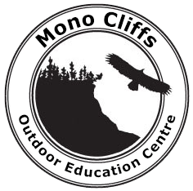
Mono Cliffs Outdoor Education Centre
tel: 905-452-0505 fax: 519 942 8712
website: schoolweb.tdsb.on.ca/monocliffs

