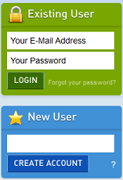
- CREATE ACCOUNT
- Visit www.myBlueprint.ca
- In the New User box, enter Activation Key “ richviewci ” and click Create Account
- Select Click to View Other Account Types > Parent
Troubleshooting Tips:
- Have an account? Enter your email/password in the Existing User box
- Forgot your password? Click on “Forgot your password?”

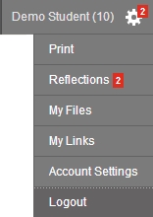
- LINK WITH YOUR CHILD (Optional)
- You can link with your child to view their myBlueprint account
- From your Home Screen, click on the Toolbox and select My Links
- Click Add Student, and search for your child by email address

- EXPLORE STUDENT FEATURES
From your Dashboard, click Go to Student View to access a demo student account to explore the features of myBlueprint.

- Post-Secondary Planner – compare detailed information on apprenticeships, college programs, university programs and workplace sectors across Canada
- Career Spectrum – complete 6 unique assessments for self-exploration and discovery (including Learning Styles, Myers-Briggs Personality, Holland Interests, Knowledge, Motivations, and Compatibility) and be matched with suited occupations
- Goal Setting – add interactive SMART goals and action plans
- High School Planner – visually plan courses, track progress toward graduation, and instantly identify post-secondary eligibility for opportunities in every pathway
- Occupation Planner – compare comprehensive information on occupations
- Resume & Cover Letter – record experiences, build a resume, write a cover letter
- Financial Planner – build a budget to track income and expenses
- Job Finder – find real-world job postings that relate to occupations of interest
- My Portfolio – create a personal or career portfolio and share it with parents, teachers, or future employers

