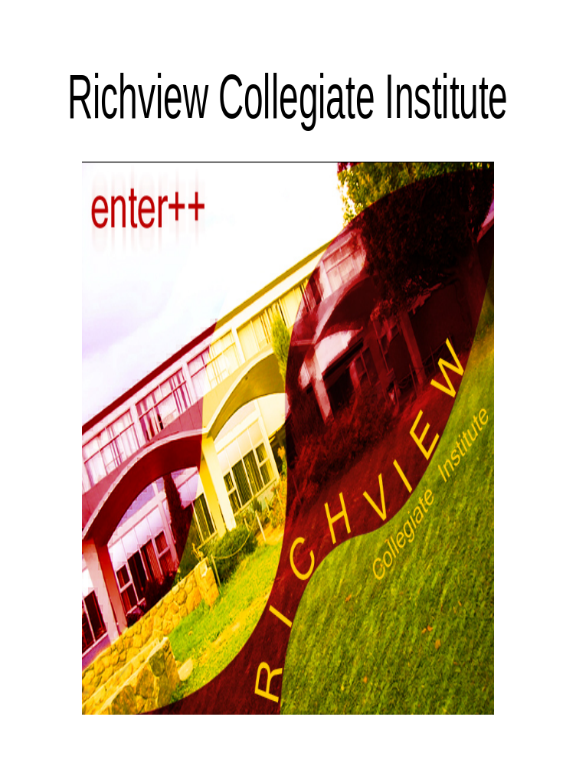
Richview Collegiate Institute

Grade 8 Information Night

Date: Tuesday, November 17, 2015

Time: 7:00 p.m.

Location: 1738 Islington Avenue
(Southwest corner of Islington Avenue &
Eglinton Avenue)

The presentation will be held in the Auditorium.

Please enter through the doors across from the tennis courts. This is nearest to the parking lot entrance off of Eglinton Avenue.

There will be break-out sessions dealing with Optional Attendance, the English program, the French Immersion program and the Extended French program.

