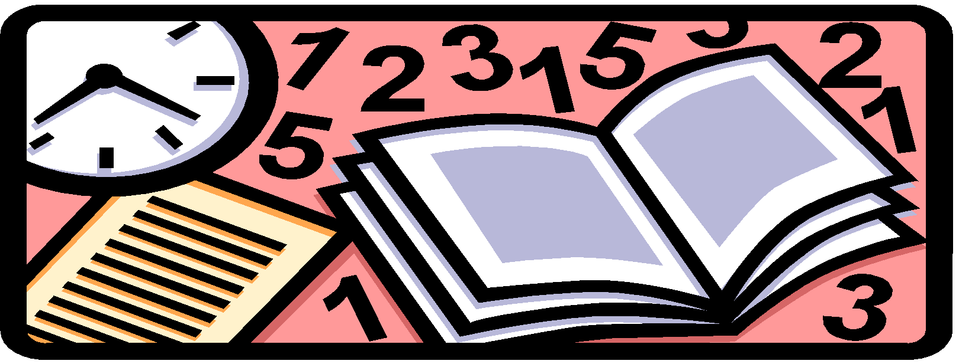

School
Day
Periods

 | REGULAR  DAY 1 / 3 |  | REGULAR  DAY 2 / 4 | LATE START | ASSEMBLY  SCHEDULE | EARLY DISMISSAL
8:45–9:45 am
Staff / Team
Meetings
Professional Learning Community
Announce-ments | 8:50 am  –  9:00 am | Announce- ments | 8:50 am  –  9:00 am | 9:50 am  -  10:00 am | 8:50 am  –  9:00 am | 8:50 am  -  9:00 am
Period 1 | 9:00 am  -  10:16 am | Period 5 | 9:00 am  -  10:16 am | 10:00 am  -  11:01 am | 9:00 am  -  10:00 am | 9:00 am  -  9:50 am
Period 2 | 10:20 am  –  11:36 am | Period 6 | 10:20 am  –  11:36 am | 11:05 am  -  12:06 am | Assembly  10:04-11:04 am  Period 2/6  11:04-12:04 pm | 9:55 am  -  10:50 pm
LUNCH | 11:36 am  –  12:31 pm | LUNCH | 11:36 am  –  12:31 pm | 12:06 pm  -  1:01 pm | 12:04 am  –  1:04 pm | Break  10:50 am  -  11:10 am
Period 3 | 12:36 pm  –  1:52 pm | Period 7 | 12:36 pm  –  1:52 pm | 1:06 pm  -  2:07 pm | 1:08 pm  -  2:08 pm | 11:15 am  -  12:10 pm
Period 4 | 1:56 pm  –  3:12 pm | Period 8 | 1:56 pm  –  3:12 pm | 2:11 pm  -  3:12 pm | 2:12 pm  –  3:12 pm | 12:15 pm  -  1:10 pm

