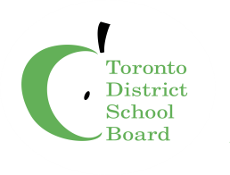
RCI SCHOOL COUNCIL
ELECTION
NOMINATION FORM

Please complete and return to richviewparentcouncil@gmail.com by October 23, 2020

received.

