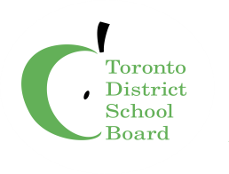
RCI PARENT COUNCIL
ELECTION
NOMINATION FORM

Please complete and return to richviewparentcouncil@gmail.com by October 8, 2020

received.

