March Break Fun for Rivercrest Families!

As we all know, March Break is quickly approaching and it is always a good idea to keep your children up and active both physically and socially through play and engagement! We have researched some events for families to get involved in the community!
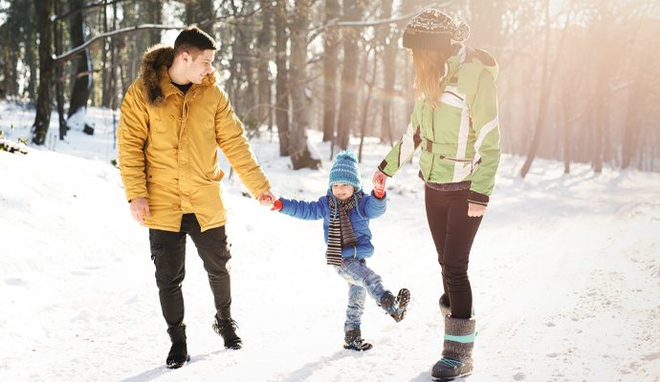

Community Events:

March Break at the Zoo – March 9th - 15th – This experience fosters child exploration and also gives children the opportunity to engage in colouring sheets, scavenger hunts, live animal visitors and much more!

March Break at the ROM – March 9th – 17th - This experience allows children to explore history of species and travel back through learning and history to India’s many kingdoms! Children and families will be able to be hands on, ask questions and take pictures!

The Berenstain Bears Live! At Rose Theatre – March 15th - During this experience, you and your child(ren) will be able to be a part of a live show! This experience is a musical adaptation of the Berenstain bears books and allows your children to learn about the importance of honesty, safety and family!

March Break at the AGO – March 9th – 17th – Throughout this experience, children of all ages will have the chance to create playful, faux sculptures of food, take family photographs, engage in a family tour, and enjoy delicious snacks!

*All information is retrieved from https://www.seetorontonow.com/annual-events/march-break-in-toronto/#sm.0000sbmpd0ople51105q4b86f6bls*

These are only a couple of the many events that are happening around our city! For more information such as: locations, prices and/or requirements/restrictions, we strongly encourage you all to look more into these wonderful opportunities that all of you will enjoy.

*** Following March Break, please return this sheet with a box checked off below***

*WAS THIS NEWSLETTER HELPFUL*
- YES
- NO

*DID YOU AND YOUR FAMILY ATTEND ANY OF THESE, OR OTHER EVENTS OVER MARCH BREAK*
- YES
- NO

