Principal: Ms. Sidhu-Thomas
Vice-Principal: Mr. Morrone
Trustee: Ms.Gill
Superintendent: Ms. Branco
Phone: (416) 394-7540
http://schoolweb.tdsb.on.ca/smithfield
 https://twitter.com/tdsb_smithfield

For student absence, please call 416 394-7540
Monday, January 14 Day 1
- A Happy Monday of Focused Learning

Tuesday, January 15 Day 2

- Tiger Movie Trip Queensway Cineplex select classes – 6F 7A 7B 7C & 7G

Wednesday, January 16

-- Tiger Movie Trip Queensway Cineplex select classes – 6A 6C 6H 7D 8B 8G 8D Day 3
– L2L every Wednesday Lunch time – Peer tutoring Peer for 15 weeks

Thursday, January 17 Day 4

-- A Happy Thursday of Focused Learning
Friday, January 18 Day 5
-- PA Day - No school for students
-- Have a wonderful weekend

SMITHFIELD M.S. UPCOMING DATE

January 31 - Wellness at NACI for Grade 8 students in the morning
February 4 – Parent Council Meeting
February 14 – Valentine’s Day
February 15 – 16 Parent Teacher interviews select students
February 18 – Happy Family Day - no school
Pizza Sales at SMS
Hello Smithfield,

The leadership team would like to remind you that we will continue to sell pizza every Friday, one slice for $1.50 and two for $2.50. So far, we have raised $1000! The grade 8 leadership team has worked very hard to reach our goal. All money raised will go towards grade 8 graduation activities. Keep up the good work, Smithfield leaders!
Prisha Patel 8G


Smithfield this Week

Athletics:
From - Smithfield Athletic Council

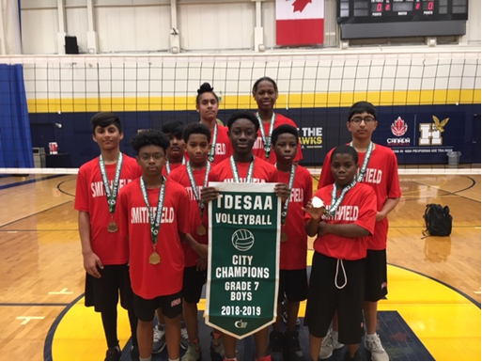
Grade 7 Boys - City Champs
Happy New Year everyone. We hope you had a wonderful New Year and may 2019 bring good health and joy in your life. We also hope that we will bring more banners and championship trophies this year. In late 2018 we won a lot banners. Here are two teams that have won banners. The grade 6s won the west conference and advanced to the city championship at Humber College. The 6s played extremely well and won the semifinal and advanced to the final game, but unfortunately lost the final in a very close match and brought home the city finalist banner. The team consisted of Om , Govind , Tyler , D’Landre , Joseph , Japjot , Adrian , Avi , Soham , Saumaya and Alex. The Grade 7 volleyball team played really well and achieved the goal to be city champions. The team consisted of Stephen, Haris, Keon, William, Sumeet, L’Markyon, Domenic ,Jason , Gurkirat, J’ziah. January and February are going to be very busy for our athletes due to a huge variety of sports they can participate in. Such as 6, 7 and 8 basketball teams, 6, 7 and 8 volleyball teams and also the 7, 8 ball hockey team. Once again we hope you have a wonderful 2019.

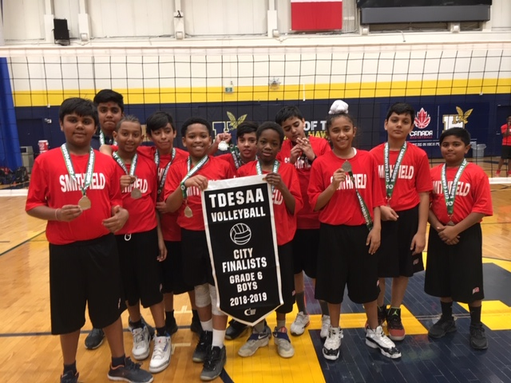
Grade 6 Boys City Champs - Runners Up

Eco- Club Tip of the Week: Remember to always try to pack a waste free lunch to help reduce garbage going into our landfills!

