Principal: Ms. Sidhu-Thomas
Vice-Principal: Mr. Morrone
Trustee: Ms.Gill
Superintendent: Ms. Branco
Phone: (416) 394-7540
http://schoolweb.tdsb.on.ca/smithfield
 https://twitter.com/tdsb_smithfield

For student absence, please call 416 394-7540
Monday, December 10 Day 1
- Character Trait Assembly – Gym First period

Tuesday, December 11

- Have a wonderful day of focused learning

- Grade 6 Boys Volleyball Conference Finals Day 2

Wednesday, December 12 Day 3
– Library Open for Grade 6 Students at Lunch

Thursday, December 13 Day 4
– 7D and 7F Young People’s Theatre Trip
Friday, December 14 Day 5
-- Have a wonderful weekend
--Grade 7 Boys Conference Finals

SMITHFIELD M.S. UPCOMING DATE

December19 -- Winter Concert
December 20 -- 7D and 7F Young People’s Theatre in school
December 21 -- Last day of school before Winter Break – dress down day - dance
January 7 -- First Day Back
January 8 -- Weston CI at Smithfield

Smithfield Apparel

T-Shirts 10 dollars
Hoodies 40 dollars
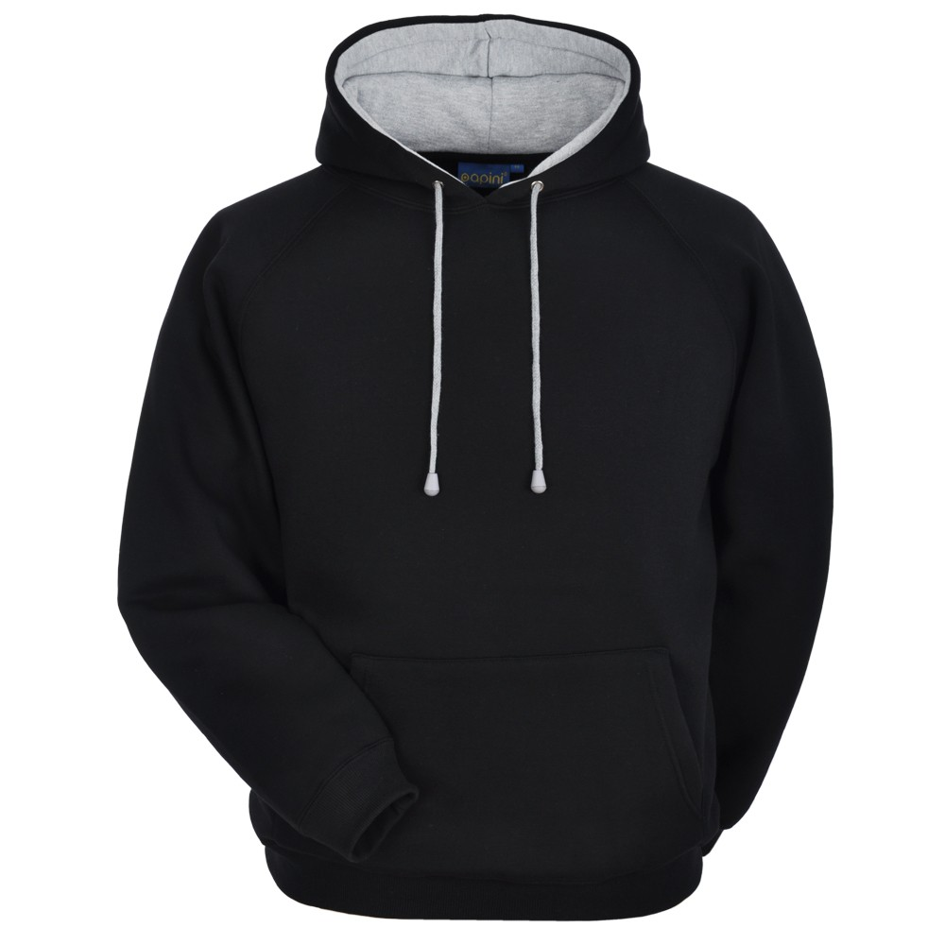
Gym bags 5 dollars



Smithfield this Week

Athletics:
From - Smithfield Athletic Council
Athletes of the Month
Smithfield Athletic Council would like to announce the Athletes of the month. Congratulations to Layla Bipta in 6A. Layla played on the football team and is an outstanding basketball player and team leader. Our male athlete of the month is Tyler Townsen in 6E. Tyler played on the grade 6 boys football team and soccer team and is currently the team captain of our grade 6 volleyball team. Both are outstanding Athletes who always demonstrate excellent sportsmanship and leadership. Congratulations Tyler and Layla
- Om Patel (Athletic Council member)
Teams:
Congratulations to our grade 6 boys’ volleyball team who won their tournament and have advanced to Conference Finals on Tuesday, December 11th. Good luck boys!

Our grade 7 boys’ volleyball team won both of their tournaments and has also advanced to West Conference Finals on Friday, December 14th. Well done team!

The Grade 8 boys have also had a successful season so far. They have advanced to play a quarter final game on December 11th. If they are victorious they too will be at Conference Finals.

SMITHFIELD CODING AND ROBOTICS MAKERSPACE

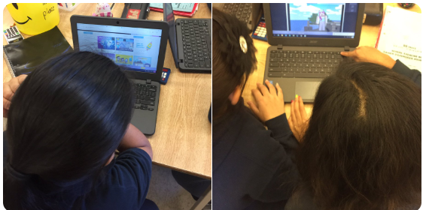

Smithfield is celebrating Computer Science Education Week by opening our new Coding and Robotics Makerspace! This lunch recess activity will be offered one-to two times per week from early December to late March. It will be open on different days of the week to ensure that students in grades 6, 7 and 8 will have opportunities to learn about programming. Students will learn to code using resources on the TDSB Hour of Code website which are highly differentiated to meet the needs of beginning, novice, experienced and advanced coders. In the Coding and Robotics Makerspace, students will also use Lego components to build working NXT and EV3 robots, which they will program to move and perform tasks using Lego Mindstorms block programming. Students should listen to the morning announcements to find out when the Makerspace is open. To learn more about coding in TDSB please visit the Hour of Code Site: https://hourofcode.com/us/learn and the TDSB Coding in the Elementary Grades Site: https://sites.google.com/a/tdsb.on.ca/coding-in-the-elementary-grades/home
To learn more about the benefits of coding, please read this edition of “What Works? Research into Practice,” a research monograph produced by Ontario Association of Deans of Education and the Student Achievement Division of the Ontario Ministry of Education: http://www.edu.gov.on.ca/eng/literacynumeracy/inspire/research/Computer_Coding_K8_en.pdf

Eco Team Tip of the Week:
To cut down on our use of plastic bottles, consider bringing a reusable water bottle to school.



