

St. Andrews Public School
60 Brimorton Drive

Scarborough, ON M1P 3Z1

Tel. 416-396-6545 Fax 416-396-6474

Principal: Kim Rainford
Office Administrator: Sherry Engbloom
Learning Network 13 Superintendent of Education: Shirley Chan
Scarborough Centre Ward 19 School Trustee: David Smith

JUNE NEWSLETTER

Happy summer vacation! Best wishes are extended to all students, staff, and families for a safe, relaxing and fun summer holiday. We would like to thank the professional and dedicated staff for their service this year. Our children are well-served by caring, capable teachers and support staff. Thank you to the St. Andrews team! Thank you School Council, parents and families for your on-going support of our school initiatives and programs this school year. Best wishes to our grade eight pupils as they begin new adventures next fall!

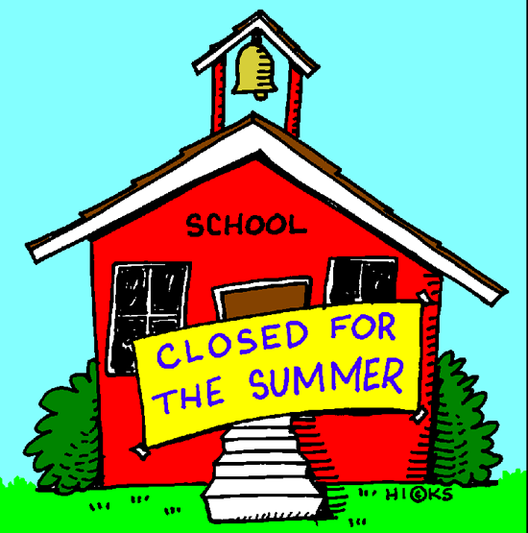
This June, we wish fond farewells to a special member of the St. Andrews staff team. We will truly miss Mr. Withrow, as he begins a new life adventure. Best wishes to Mr. Withrow who is retiring from his TDSB teaching career. Thank you for your many years of service to the children and families of Scarborough! We will miss you and we thank you for your time with us! Thank your for your teamwork and many contributions to academic and co-curricular life at St. Andrews!


Joining the St. Andrews Team this fall, special welcome to Ms. N. Allahyar who joins our staff in the mornings. Ms. Allahyar will continue to teach at Mary Shadd PS in the afternoons. Welcome Ms. Allayhar! The first day of school is Tues. September 3, 2019. All students will gather on the pavement at the back of the school to meet their teachers for September. All teachers will have signs indicating their grade and classrooms, with the list of the students for their classes. In the event of rain, all Primary students will gather in the gym and all Junior students will gather in the front hallway with the teachers and their lists of student names for their classes.

St. Andrews gratefully thanks our Office Administrator Mrs. Engbloom for her dedicated efforts to the students, staff, families, and the school. Special thanks to Mr. Eckert and Mr. Clamohoy for their dedicated efforts and energy to keep our school sparkling inside and outside. Many thanks to all of our support staff in the classrooms and lunchroom for their dedication and hard work with our students, and to our TDSB professionals in Special Education, Guidance, Psychology, Social Work, Speech and Language and other programs. Thank you very much!

June is a month of many special events acknowledged by Canada, TDSB and St. Andrews PS. June features Pride Month, Italian Heritage Month, Portugese Speaking Heritage Month. June features Father’s Day, Indigenous History Month/Indigenous Day on June 21st, the Summer Solstice. Ramadan ended this June, with Eid al Fitr celebrations, Eid Mubarak!

The Toronto Parks, Forestry & Recreation Department offers summer day camp programs for children. Please refer to the Toronto Fun Guide. Visit their site at toronto.ca/torontofun. For Toronto-based summer adventures for children and families, visit toronto.ca/parks. The Toronto Public Library also offers complimentary family passes to visit local Toronto attractions for free. Stay active, healthy and fit this summer. Practice reading, play with friends, and enjoy outdoor summer weather!




Our Track & Field season concluded this June. Mr. Withrow, Ms. Brown, Mr. Denov and the St. Andrews staff are commended for their leadership and coaching talents for our athletes. Several of our pupils advanced to the Toronto City Finals, with outstanding results! Congratulations St. Andrews! Our Folkdance season concluded this month with a spectacular Jamboree showcase at Cedarbrae CI. Thank you folk dance coaches: Mrs. Silver, Mrs. Minniti, Ms. Punia, Ms. Awara, and the Primary and Junior Folkdancers!! It was a splendid performance! The Intermediate Quebec City Trip took place in June, with a safe and happy time of history and French language learning brought to life. Special thanks to Ms. Brown for her leadership and organization and to our staff supervisors: Ms. Awara, Mr. Bartlett and Mr. Georgakopoulos! Jump Rope for Heart occurred this June. With thanks to Mr. Volpe and Mrs. Silver for their leadership and coordination!! Thank you to the St. Andrews families and students for raising funds for a charity close to everyone’s heart, the Heart and Stroke Foundation.


Kindergartens have been actively learning, planting, rehearsing and playing this month. Thanks to the Kindergarten teachers and their helpers for a special Play Day event! It was a beautiful day to enjoy fitness, sunshine and fun outdoors in the Kinder Garden area. Many thanks to Mr. Truong, Mr. Gregg, Mrs. Hanna, Ms. Bots, Mrs. Huerto, Mrs. Cameron, Ms. Sander and Kindergarten staff and student helpers for their excellent performance to celebrate life in Kindergarten this spring! All we need to know, we learned in Kindergarten!! A wonderful afternoon of student performances and parent visits were greatly appreciated.


Grade 8 students were honoured and celebrated at their graduation ceremony this month. Congratulations Grade Eight Graduates!! Students received certificates and recognition for significant St. Andrews awards. Special thanks to Ms. Hendershot, Ms. Awara, Mr. Volpe, and Mr. Withrow for their leadership. A thank you to Ms. Awara for her hardwork with the yearbook. Many thanks to Ms. Brown, Mr. Denov, Ms. Solomon, Mr. Georgakopoulos, Mr. Bartlett for their assistance and to Mr. Lewis for attending. The graduates and families enjoyed a wonderful celebration of learning and success! Our School Council, Student Council and parent volunteers Mrs. Daicopoulos and Mrs. Bangee are thanked for their generous support, time, and resources. The Intermediate students’ Freezie Friday fundraising event was a profitable success to support the students’ graduation, including the families’ contributions. Well done Graduation committee and students!

The St. Andrews PS School Council is thanked and appreciated for their hard work this school year, culminating in a very successful annual Fun Fair event! The Fun Fair Committee provided many hours of preparation and organization. Our event was opened by the reading of the Indigenous Land Acknowledgement and continued to be an evening of food, fun, and festivities!! The volunteers and Bake Sale provisions from St. Andrews parents/guardians, former and current students all helped to set up, clean up, and lead activity stations and ticket sales for this event. Thank you to staff members who worked alongside organizers and volunteers to make this year’s event great! The prize donations from St. Andrews families, classrooms, private businesses sponsorships and organizations in our community and the City of Toronto were greatly appreciated!! Special thanks to Deputy Mayor, Michael Thompson and his staff for their attendance, Toronto Raptor button-making station and prize donation. Special thanks to Toronto Police Services for Officers Julie and Chris for their attendance, representing 43 Division, and to their police colleague from the Mounted Division who attended the event on horseback! Special thanks to Mr. Kim and the Thomson CI Robotics Team for their presentation and demonstrations of STEAM in action! St. Andrews and its supporters are spectacular and we appreciate you!


St. Andrews is a productive school because of our many volunteers who work hard to support the work of students and staff. Many thanks to Mrs. Engbloom for coordinating our volunteer applications and Police Reference Checks. All parents/guardians are welcome to volunteer at our school, including attending classroom and school trips, with a Toronto Police Services-Vulnerable Sector Clearance Police Check and TDSB Volunteer Data Base registration. Please ensure that you update your TDSB Volunteer Data Base registration annually, by June 30/19 so that your name remains current and active for volunteer service in 2019-2020. We look forward to working with you and having you attend trips with your children. Please get you Police Check and Data Base registration completed. THANK YOU ST. ANDREWS VOLUNTEERS!!


In community news, thank you to Trustee David Smith for his annual Ward 17 School Community Fun Fair at Glamorgan PS. Great weather for great times, to celebrate the successes of the school year, including special awards donated to 2 St. Andrews PS students. Thank you Trustee Smith! Deputy Mayor Michael Thompson invites the St. Andrews community to Outdoor Movie Nights this summer. The movies begin at 9 p.m. on the following Friday evening dates: July 12, July 18, August 2. These movies: Flipped, Wonder, and Coco will be shown at Dorset Park, Knob Hill Park, and Maidavale Park. For additional information, Councillor Thompson’s office can be contacted at (416) 397-9274 or www.COUNCILLORTHOMPSON.COM .

St. Andrews appreciates the additional work of our school staff for their organizational plans to recognize student achievement. The Grade 4-8 Awards Assembly staff and students are thanked for their recognition of our pupils. Thank you to Ms. Awara for her leadership, with presentations from Ms. Hendershot, Mr. Lewis, Mr. Georgakopoulos, and support from Mr. Withrow, Mrs. Silver, Mr. Eckert and Mr. Volpe. It was wonderful to have parents and family members in attendance to celebrate our students’ hard work, accomplishments and perseverance. St. Andrews students have enjoyed a busy and productive school year. Celebrate your successes students and have a wonderful summer! Thank you for your support this year. We look forward to working together next year. Best wishes for a healthy, safe, happy and restful summer!!


Ms. Rainford
Principal

