

St. Andrews Public School
60 Brimorton Drive

Scarborough, ON M1P 3Z1

Tel. 416-396-6545 Fax 416-396-6474

Principal: Kim Rainford
Office Administrator: Sherry Engbloom
Secretary: Mary Kalogirou
Learning Network 13 Superintendent of Education: Lynn Strangway
Scarborough Centre Ward 19 School Trustee: David Smith

NOVEMBER-DECEMBER NEWSLETTER



Season’s Greetings to all St. Andrews PS students, and families. On behalf of the staff, we wish you a safe, healthy and happy holiday and a prosperous New Year!

Winter officially arrives this season with the arrival of the Winter Solstice on Dec. 21st.

Please ensure that you check the daily weather reports and dress your child/ren appropriately for the weather. All children go outdoors for recess and lunch times. Please label your child’s coat, snow pants, boots, hat, mittens, and scarf with his/her name in case these items get lost. Extra socks, mittens, or other items of clothing are practical additions to your child’s backpack during the winter season. Your child can change into warm, dry clothing if he/she becomes wet.

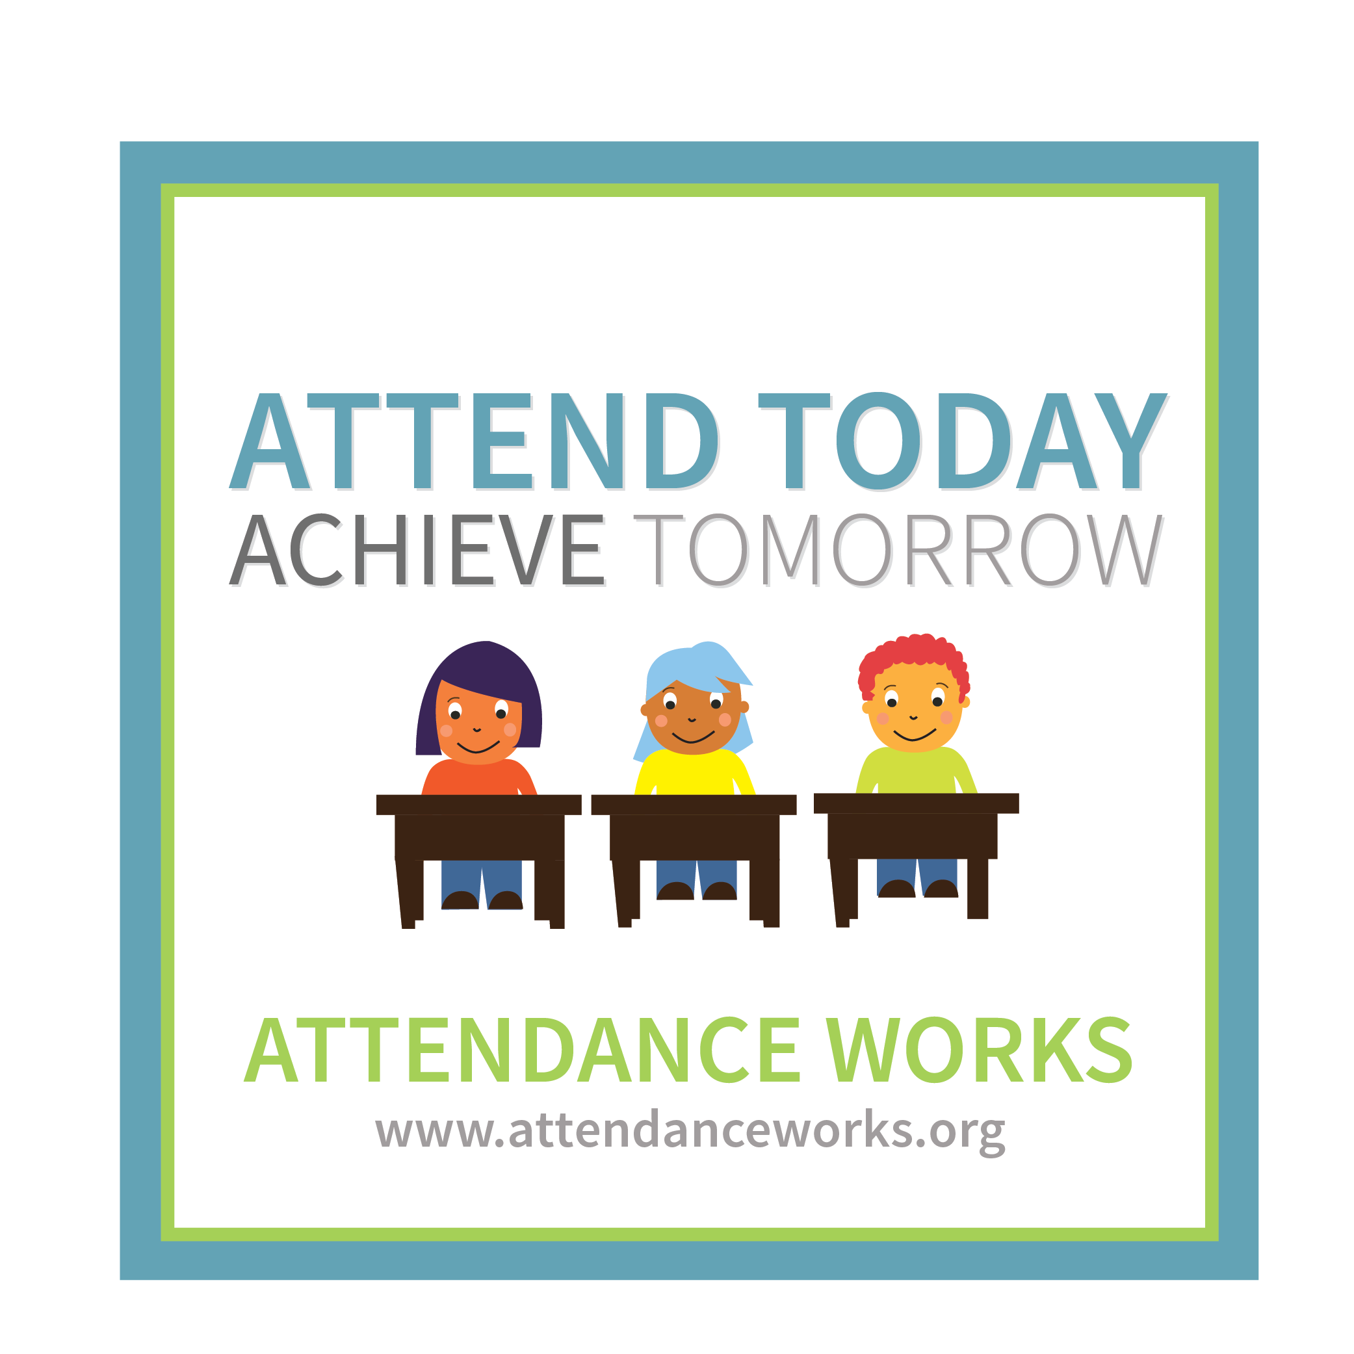
Winter preparations also require plans for additional time. Trends in the office indicate that there are increasing numbers of students arriving late to school on a regular basis! It will always take additional time for families to navigate apartment building elevators. Winter weather dictates additional time for outdoor dressing, walking through snow and ice and driving slowly and carefully. Please plan ahead to have your child/ren arrive at school by 8:40 a.m. and 12:25 p.m. at entry bell times to enter the school in their class line-ups. Prompt arrival and regular attendance are critical keys to your child’s academic success at school. If your child will be absent from school, kindly telephone the office to leave a message for the staff about the reason for the absence. Students who are establishing patterns of lateness will be sent home with parent letters to improve punctuality. Likewise, the TDSB Synervoice automated telephone system will contact parents in the case of student lateness or absences. Parents must listen to the entire message and press the correct button to stop the automated system from calling them. School Office staff cannot stop the TDSB Synervoice call-outs to parents.


This winter, TDSB snow plowing procedures indicate that plowing will not take place in the school yard. All students, staff, parents, and community members are asked to use care and caution when walking on the paved school yard at the back of the building. Proper winter boots are essential for everyone outdoors at St. Andrews. Attention to icy surfaces is necessary to avoid slips and falls. Please be careful on the paved areas! Thank you.

In staffing updates, St. Andrews PS wishes Mrs. Mehta well during her leave of absence from Jan.-May 2020. During this time, we welcome Ms. C. Fyffe to work with the students and staff in room 103. Mrs. Kalogirou is thanked for her continued service in our school office each morning. Mr. Caprio, Mrs. Das, and Mr. Leyland continue their service until June 2020. Mr. Gregg remains on a leave of absence until further notice. With thanks to Mr. Ismail and Ms. Trajanovski for their service working with the students and staff of room 114. We are thankful for our Long Term Occasional Staff!

Many thanks to our staff leaders for extra-curricular activites for our students.

Ms. Brown, with assistance from Ms. Trajanovski and Ms. Baker organized the Gr. 7 / 8 girls’ volleyball team. Mr. Caprio coaches the Gr. 7 / 8 boys’ basketball team. Ms. Awara and Mr. Denov lead the Intermediate Student Council who organized Crazy Hair Spirit Day. Mr. Denov coaches the Gr. 5 / 6 boys’ basketball team. Mrs. Silver and Ms. Awara work with our partners in the Mathematics Knowledge Network and took students to the STEAM 3D Maker Lab at Ontario Tech University. Ms. Punia continues to lead and supervise the Faculty of Education Teacher Candidates from York University. Mr. Volpe supervised Faculty of Education Students from Ontario Tech University, Ms. Arbach and Ms. Fountain who worked with our students and staff to conduct classroom lessons in math/art/coding. Our staff are very busy inside and outside the classrooms with teaching, learning, and leading additional opportunities for students to have leadership, and participation in a wide variety of activities. Thank you staff!



Mr. Volpe is thanked for his leadership and organization of the annual St. Andrews Read-A-Thon, resulting in a school fundraising initiative of $8040.60. Many thanks to the students for their extra reading and to parents and families for supporting this school fundraising initiative! Ms. Awara, Mr. Denov, the WE Club and the students and families are thanked as many boxes of food items were collected and donated to the local food bank. Thank you students and families! Valerie Todd, Food Bank Coordinator of the St. Ninian’s Food Bank (a member agency of Daily Bread) writes: “Thank you so much to all the students and staff involved in giving the very large donation of food to St. Ninian’s Food Bank. We have never had so much food given in a single donation. It was wonderful to see the students bring the food with such joy to be helping the hungry. This week (Nov. 22nd), we had 163 households come for food. This fed 477 people of which 180 were children. We appreciate you joining with us to feed the hungry in our community.”

With thanks to Toronto Public Health this November for screening all students at St. Andrews PS for dental health. Oral health is overall health and we appreciate the time and talents of this City of Toronto team. Similarly, special thanks to Toronto Public Health nurse, Diane Ferrara for her Pediculosis (head lice) training, and screening. Parent volunteer leaders, Mrs. Korsal and Mrs. Giza led the training with other parent volunteers to create a team of trained parents to screen our students to detect the presence of head lice. Trained parent volunteers also re-check students who return to school from home treatments. Kindly check your child’s hair weekly to ensure that head lice are not present and inform the school if so, so that classroom checks can be conducted by our team of trained parent volunteers. Many thanks.


Our School Council has been very busy meeting, planning and leading special events. Karen Kerry from Aisling Discoveries Child and Family Centre presented a Parent Workshop on Bullying. Family Holiday Movie Night took place this month. A Holiday Gift Card Fundraising program featuring Oxford Shopping Centres- STC occurred this month, and an upcoming Valentine’s Day Family Outdoor Fun Day will take place in February, as well as an Indigo-Chapters February school fundraiser. More details will follow. Many thanks to our School Council parents and volunteers!! Thank you to our gr. 7 & 8 students for their leadership assistance! We appreciate monthly Pizza Lunches and the special activities planned by the School Council and the support of many school volunteers in the classrooms, on excursions, assisting with special events, and in the lunchroom.

SCHOOL CASH ON-LINE ANNOUNCEMENT:
If parents/guardians make name or email changes, this information must be recorded in the KEV account system. Please log into your KEV account to update the information in order to receive email communications or receipts with your proper name. Thank you for your attention to these important details.

Safety:
Please do NOT enter the parking lot at any time to drop off or pick up students at any time! Please do NOT block the crosswalks or neighbour’s driveways on Brimorton Dr. or Packard Blvd! When entering the school, Door 1, the front door, with the doorbell is the access door for parents and visitors to the school. Door 5 is only for use by the gr. 2 / 3 and gr. 5 classes. Many thanks for your cooperation with these reminders.


Lunchroom reminder: Please do not bring glass containers to school for lunch! Please do NOT send any food items containing nuts, traces of nuts, or may contain nuts!!! If an adult is at home during the lunch time, it is expected that students go home for lunch. The lunchroom is VERY crowded, and loud, with only 3 adults to supervise hundreds of children.

When calling the school office, parents are reminded to check voice mail messages first, so that it is clear which staff member contacted you from the school. Often parents will call the school, without checking the messages first to hear the name of the teacher or administrator that is trying to contact the parent. The main office staff have no way of verifying who called a parent. Thanks for checking before you return the phone call.

Parents and families are reminded to check and use the student agenda planners on a daily basis. Ask your son/daughter to show you his/her agenda at home every evening. Students should be using the agendas in class to record homework assignments, notes, reminders, etc. from the teacher/class. On some occasions, the agenda may not have a note written in it, but it is advisable for parents to check daily. Additionally, if parents are uncertain about school work, assignments, projects, tests, etc., parents should write a note to the classroom teacher in the agenda. Phone calls to teachers are also welcome. Teachers are not able to meet with parents without appointments. They cannot take phone calls immediately, but they can return your phone call if you leave a message for them. Clear and regular communication between parents and teachers is important to benefit students and their learning at school and at home. If parents have questions/concerns, please don’t wait for formal interview times to discuss your child’s needs. Speak with the teacher regularly.


All students are reminded that outdoor soccer & footballs must be played with on the field. Tennis balls, basketballs and other soft balls are acceptable on the pavement. Parents and caregivers who walk their children to and from school are reminded to be mindful of ball playing areas on the pavement for children. We encourage and promote fresh air and healthy outdoor play every day! Outdoor play must be safe and respectful!! Please speak to your child about keeping his/her hands to himself/herself. Aggressive play is rough and it causes injuries and insults to other children. There is no need to play games that involve grabbing, pushing, shoving, or hitting. Likewise, snowball throwing is not permitted, as it is not safe. Do not throw snow!! Parents are reminded to read and review the student agendas to encourage respectful and positive behaviours at school.

Happy Winter Solstice, Happy Hanukkah, Merry Christmas, Happy Kwanzaa, Happy Boxing Day, Happy New Year, Merry Orthodox Christmas!!

Sincerely,

Ms. K. Rainford
Principal





