Sun | Mon  Twentieth Street Junior School  October 2021  Responsibility | Tue | Wed | Thu | Fri | Sat
 | Remember to Bring Your Signed Health Pass Every Day.  Bring an extra mask with you daily as well.  October is International Walk to School Month. |  |  |  | Day 2 | 2  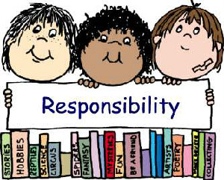
3 | 4  Day 3 | 5  School Council Mtg  7:00 pm.  Virtual Mtg  Sign-Up to receive the Zoom Link  World Teacher’s Day  Day 4 | 6  Day 5 | 7  Day 1 | 8  Day 2 | 9  IMAGINATION  Never be limited by other people’s limited imaginations.  Mae Jemison
10 | 11 | 12  Day 3 | 13  Day 4 | 14  Day 5 | 15  Day 1 | 16
17 | 18  Day 2 | 19  Day 3 | 20  Day 4 | 21  Photo Day  Day 5 | 22  Day 1 | 23
24 | 25  Day 2 | 26  Day 3 | 27  Day 4 | 28  Day 5 | 29  Day 1 | 30
31
Happy Halloween

