[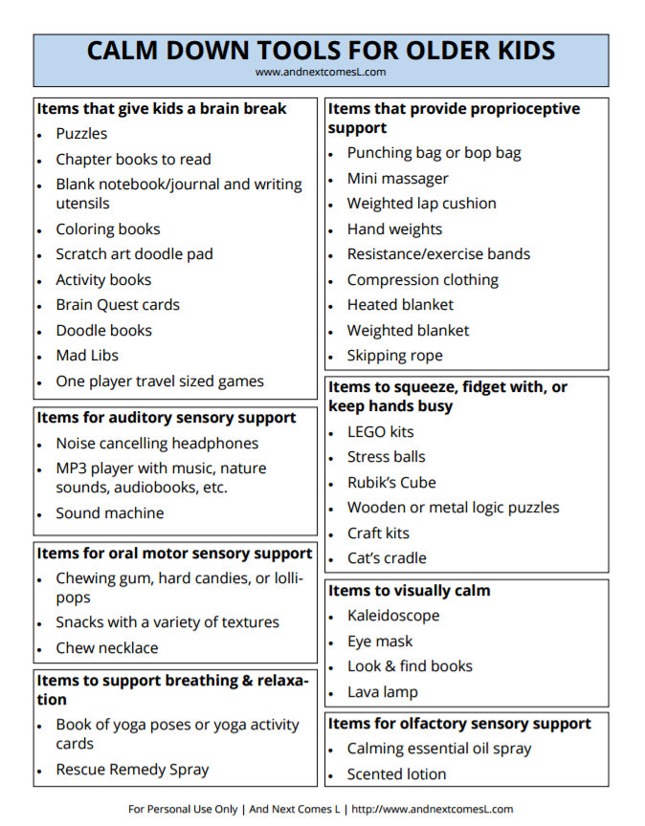](http://www.andnextcomesl.com/p/autism-sensory-cheat-sheets.html)