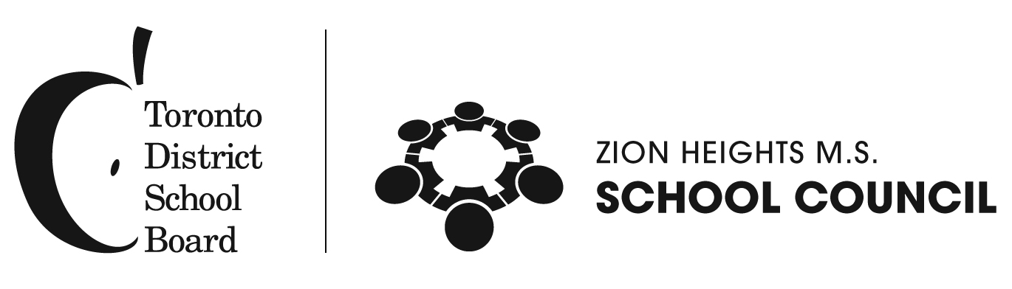

Dear Parents/Guardians: September 6, 2018

Re: Zion Heights MS – School Council 2018-2019
Studies have shown that students whose parents/guardians are involved in their education do better in school.

School Councils were created to improve student achievement and enhance the accountability of the education system to parents through the cooperative efforts of parents, staff members and others in the community.

Your School Council is an advisory body of volunteers who work together to provide ideas and opinions to help the Principal, and sometimes the School Board, make Zion Heights MS a better place for our children to learn. The School Council provides a forum for discussing educational issues. It also provides a way to get information to parents/guardians, get feedback from them, and present their ideas and concerns.

School Council meetings are open to all parents and guardians and everyone is invited and encouraged to attend, to learn more about Zion Heights MS, the Toronto District School Board, and topics of value to parents on educational and related matters. School Council meetings are generally held once a month from 6:45 to about 8:45 pm. Our first School Council meeting of this year will be on Wednesday, September 26 @ 6:45 pm in the Teacher’s Lounge, and all parents and guardians are invited.

Re: School Council Elections
A great way to get involved is to let your name stand for nomination to the School Council. Should you wish to participate on a regular basis on our School Council, please fill out the nomination form included in this mailing. A person is qualified to be elected to a parent member position on our School Council Executive if he/she is a parent/guardian of a student in the school. Note: Board employees who work at their child’s school are not eligible for election as school council parent members in that school (Reg. 612/3.5, 4.2). The deadline for nomination forms to be returned to the school office is 4:00pm Friday, September 14, 2018.

The election will take place at the first School Council Annual General Meeting on Wednesday, September 26, 2018 @ 6:45 pm. Candidate information (based on the attached form) will be posted on the School Council bulletin board from Monday, September 17 – 21. Please see the attached School Council Election Q and A for additional information.

Should you have any questions, please contact our current School Council Co-Chair Phouvieng Sackda or Sajuli Liscombe at (phouv@rogers.com or sajulijl@yahoo.com.

Yours truly,

S. Sidlofsky
Principal

