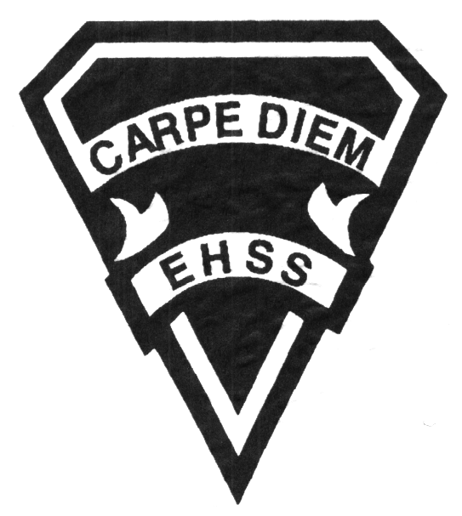

**TEJ2O**

**Open -No Prerequisite**

**Computer Studies**

**Department**

**Gr.10 Computer Technology**

**Evaluation Profile**

## Earl Haig

SecondarySchool

**Course Description/Rationale/Overview:**

This course introducers students to computer systems, networking, and interfacing, as well as electronics and robotics, Based on CISCO Academy IT Essentials curriculum, students will learn how to assemble, repair, and configure computers with various types of operating systems and application software. Students will also develop and awareness of related environmental and societal issues, and will learn about secondary and postsecondary pathways and career opportunities in computer technology.

**Assessment and Evaluation Strategies**

**Assessment:**

Students will be assessed using a variety of strategies including homework checks diagnostic tests/quizzes, peer assessment, reflection writing and observation.

**Evaluation:**

Students will be evaluated using a variety of strategies including tests, quizzes, written/oral reports, essays, research assignments and presentations.

**Note:** the strategies are not limited to the above mentioned.

**Class Requirements:**

Students are expected to come to each class, bring writing utensils and USB Key with at LEAST 2 GB of personal storage and backup.

Students will be registered with CISCO Academy and teacher will recommend online resources.

**Late and/or Missed Evaluation**

Late Assignments: Late assignments must be accompanied by a note signed by a parent/guardian stating the reason for late submission. The note must indicate the due date of the assignment and the actual date of submission.  *Marks may be deducted for late assignments, up to and including the full value of the assignment.  [Growing Success: Assessment, Evaluation, & Reporting in Ontario Schools, Ministry of Ontario, 2010, p. 43.]*

Note: If an assignment is handed in after it has been marked or feedback has been provided to students/class, it may no longer be accepted except for special circumstances.

**Missed Tests** It is the student’s responsibility to make arrangements, ahead of time, for any tests/quizzes that are missed. If a student misses a test/quiz for an unforeseen reason such as illness, the student must bring a note signed by a parent or guardian and be prepared to write the test/quiz immediately upon return to school.

*Once a test or quiz has been taken up or handed back the student may not receive a mark for it.*

**Learning Skills\***

**Responsibility** – meets deadlines; takes responsibility for own behaviour

**Organization** – establishes priorities and manages time; uses information, technology and resources top complete tasks time management

**Independent Work** – follows instruction with minimal supervision; uses class time appropriately to complete tasks

**Collaboration** – accepts an equitable share of work in a group; builds healthy peer relationships; works with others to achieve group goals

**Initiative** – looks for opportunities for learning; demonstrates curiosity; approaches new tasks with a positive attitude

**Self-regulation** – sets own goals and monitors own progress; seeks assistance with needed; makes an effort with responding to challenges

**Subject-Specific/Department Information**

Dept Office: Room 268

Dept extension: 20115

Extra Help is available. Please speak with teacher individually.

**Note:** Please speak with individual teachers for contact info.

###### Final Mark

**Year’s Work 70%**

As per the above mentioned, students will be evaluation using many different strategies.

**Final Summative Exam/Evaluation 30%**

Students develop a small pieces of software that will reflect all their programming knowledge, as well as their written/oral communication skills. There will be different parts to the final summative evaluation.

**Achievement Categories and Weighting**

* **Knowledge / Understanding 14 %**: knowledge of facts and terms; understanding of concepts, principles, guidelines and strategies; understanding of relationships among concepts.
* **Application 28 %**: Applying base knowledge concept to writing proper computer code.
* **Thinking Inquiry 14%:** Planning out computer software program by selecting and using proper planning strategies/methods
* **Communication 14%**:Communication of information and ideas, communication for different audiences, use of various forms of communication.

*From: Ontario Ministry of Education. *Growing Success: Assessment, Evaluation, and Reporting in Ontario Schools*. Toronto: Ministry of Education, 2010, 11.



## Earl Haig

SecondarySchool

**TEJ2O**

**No Prerequisite**

**Computer Studies**

**Department**

**Computer Engineering**

**Outline**

|  |  |  |  |  |  |
| --- | --- | --- | --- | --- | --- |
| **Course Outline:** | | | | | |
|  | **Unit** | **Description** | **Approximate Length** | |
|  | Unit 1  Computer Hardware | Students identify and explain the functions of the basic components of a computer, basic circuits, and peripheral devices. Emphasis is placed on safety as students handle a variety of tools, equipment, and internal and external components. | 15 classes | |
|  | Unit 2  Data Representation and Digital Logic | The focus of this unit is on integrated circuits and how the internal workings of a computer represent data such as characters and numbers. Students learn standard codes for internal numbering and character representation. They learn to design and construct fundamental logic gates (i.e., AND, OR, NOR, NAND, NOT, XOR, XNOR). They also learn about and construct simple electronic circuits, apply Boolean algebra, and devise truth tables to test and describe their functionality. Students develop an understanding of gates, semi-conductors (e.g., transistors, diodes, etc.), and integrated circuits by designing and building simple logic gates. | 5 classes | |
|  | Unit 2  Computer Networks | Students explore and set up parallel and series computer communication processes within a computer and between computer systems (e.g., internal architecture, cabling standards, topology, and network types). They use problem-solving skills to apply their knowledge to tasks such as researching simple network types and building simple communication networks. Students also learn about the importance of network connectivity and infrastructure and how it impacts on our world as well as potential career opportunities in the area of computer networking. | 20 classes | |
|  | Technology, Environment and Society | Describe key aspects of the impact of computers and related technologies on society.  Describe computer use policies that promote environmental stewardship and sustainability.  Describe legal and ethical issues related to the use of computing devices.  Describe post-secondary education and career prospects related to computer studies. | 10 classes | |
|  | Unit 3  Introduction to Arduino and  Programming | This unit focuses on how to program a computer using a problem-solving model. This model helps to organize and develop the fundamental structures of programming. These fundamental structures include variable declarations, assignment statements, input/output, selection, and looping. Each structure builds upon and is incorporated into subsequent structures. The programming software introduced in this unit allows students to write simple programs which integrates with hardware to control external devices and peripherals. Students also research and identify computer-related careers and explore ergonomics. | 15 classes | |
|  | ISU final  project | The final culminating unit incorporates information learned in all previous units. Students are expected to work activities that will prepare them for the challenge of a Final Project in which they demonstrate their knowledge of integrating software and hardware processes to solve an interfacing challenge. | 20 classes | |
|  | **Note: The order of the units of study may change due to student needs and resources available during the course.** | | |  | |