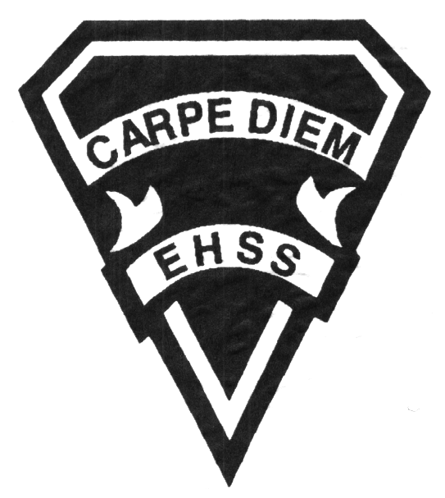

ATM2OP

GR.10 MODERN DANCE

Earl Haig
SecondarySchool

ATM 2OP
Evaluation Profile & Outline
Course Description/Rationale/Overview:
This course emphasizes the development of technical proficiency within the class and choreographic settings. Students will develop their modern training (Martha Graham) with increasingly difficult skills; study historical and cultural aspects of dance, anatomy; develop their improvisational skills, learn and incorporate stage-craft, create and present complex compositions; and analyze and evaluate dance.

Assessment and Evaluation Strategies
Diagnostic, formative, summative, rubrics

Assessments:
Homework checks, peer assessments, presentations, reflective writing, observation, self/teacher checklist, student/ teacher conferencing

Evaluation:
Unit tests, assignments, performances, oral presentations, journals, jury test

Class Requirements:

Dance Journal
- Reflection, Technical Notes

Dance Attire:
- See Dance Handbook

Lost Costume
  - Replacement cost:
$75 - $125

Late and/or Missed Evaluation
Our policy on late assignments and missed tests is in complete agreement with the school-wide policy. Late assignments must be accompanied with a note signed by a parent or guardian stating the reason for tardiness of the assignment. The note must list the due date of the assignment and the actual date of submission. If an assignment is handed in after it has been taken up/ handed back, the student may not receive a mark for it.

Learning Skills

Responsibility – meets deadlines; takes responsibility for own behaviour
Organization – establishes priorities and manages time; uses information, technology and resources top complete tasks time management
Independent Work – follows instruction with minimal supervision; uses class time appropriately to complete tasks
Collaboration – accepts an equitable share of work in a group; builds healthy peer relationships; works with others to achieve group goals
Initiative – looks for opportunities for learning; demonstrates curiosity; approaches new tasks with a positive attitude
Self-regulation – sets own goals and monitors own progress; seeks assistance with needed; makes an effort with responding to challenges

Dancewear & Lateness:
Being late, or without proper dancewear can cause injury and stress on the dancer’s body without a proper warm-up.
After five times LATE: you will not be permitted to participate in the class.You will fulfill an observation assignment.

Attendance
Students are evaluated daily for evidence of work. Failure to attend results in missed opportunities for studio work and a lack of teacher clarification and feedback. If a student is absent, they must bring a parent/guardian note and be responsible for all missed work. It is not the teacher’s responsibility to notify the student of missed work. The student must take an active role in the course material.

Final Mark

Year’s Work 70%
Unit work, presentations, written work, research, choreography, rehearsals, performances, studio work

Final Summative Evaluation 30%
Dance Creation Project- choreography, practical work (rehearsal and performance), written work.

Achievement Categories and Weighting

Knowledge / Understanding 30%: Knowledge of facts and dance terminology; Understanding of technique, theory, choreography; knowledge of stage craft

Application 35%: Active participation, dance etiquette, technique, safety, behaviour, Improvement, rehearsal process

Thinking Inquiry 10%: Analyzing and interpreting technique method, history, research, Critiques, resources in the dance community.

Communication 25% Communication for different audiences, performance of student work and class work, communication of ideas, rehearsal process, Dance Night.

Earl Haig S.S. Claude Watson Secondary Arts Program

ATM 2OP

Evaluation Profile & Outline

OVERALL EXPECTATIONS
GRADE 10
- Creating, Presenting, and Performing
A1. The Creative Process: use the creative process, the elements of dance and a variety of sources to develop movement vocabulary;
A2. Choreography and Composition: combine the elements of dance in a variety of ways in composing individual and ensemble dance creations;
A3. Dance Techniques: demonstrate an understanding of the dance techniques and movement vocabularies of a variety of dance forms from around the world;
A4. Performance: apply dance presentation skills in a variety of contexts and performances.

- Reflecting, Responding and Analyzing
B1. The Critical Analysis Process: use the analysis process to reflect on and evaluate their own and others’ dance works and activities;
B2. Dance and Society: demonstrate an understanding of how societies present and past use or have used dance, and how creating and viewing dance can benefit individuals, groups and communities;
B3. Connections Beyond the Classroom: demonstrate an understanding of the purpose and possibilities of continuing engagement in dance arts.

- Foundations
C1. Physiology and Terminology: demonstrate an understanding of and use correct terminology when referring to, the physiology of movement as it relates to dance;
C2. Contexts and Influences: demonstrate an understanding of the social, cultural and historical origins and development of dance forms, including their influence on each other and on society;
C3. Responsible Practices: demonstrate an understanding of safe, ethical and responsible personal and interpersonal practices in dance activities.

COURSE OUTLINE
- Technique – Conditioning, Graham
- Modern Jury Test
- Guest Choreography
- Field Trip
- Health and Safety Initiatives Project - Anatomy
- Self and the Community-Values, Integration, Participation in Related Arts and Culture
- Improvisation and Choreography
- Presentation and Performance
- Production: Dance Collective Night – Backstage, Front of House, Choreography, Performance
- History and Culture
- SUMMATIVE: Exploration and Research/Reflection and Reportage

PERFORMANCE PARTICIPATION DATE FOR STUDENTS

Claude Watson Open House: Thursday, November 8, 2018- 6:00 PM

Dance Matinées: Tuesday, April 9, 2019 - 10AM/1130AM/1:00PM

Dance Night: Wednesday, April 10, 2019 - 7:00 PM

Dance Collective Night: Wednesday, May 8, 2019, 7:00 PM

CONTACT: Dance Department: 416-395-3824 Ext: 20139

