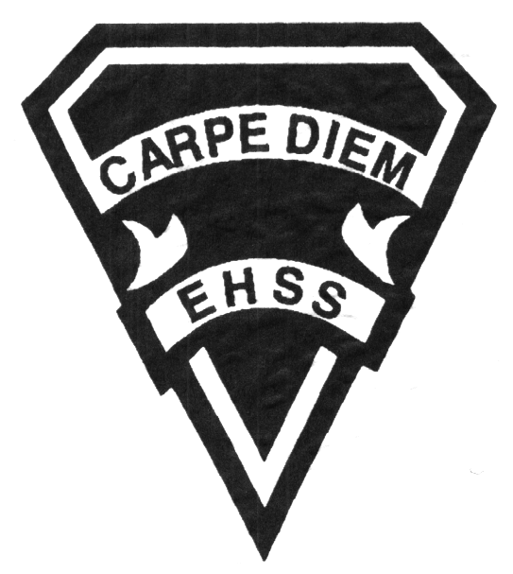

**Course Description/Rationale/Overview**

This course extends the range of analytic reading, writing, oral communication, and thinking skills that students need for success in secondary school academic programs. Students will study and interpret challenging texts from, including novels, poems, plays, opinion pieces, and electronic sources, and will analyse and create effective media works. An important focus will be the thoughtful use of spoken and written language, revision and editing.

##### Enriched English ENG1D3

Enriched courses follow the curriculum for academic courses. It is the manner in which the course is delivered, however, that will be different for Enriched classes.

### English Grade 9 Enriched

English Department

## Earl Haig

SecondarySchool

# **ENG1D3**

**Evaluation Profile and Outline**

**Assessment and Evaluation Strategies**

**Assessment:** Checklists, rubrics, performances and demonstrations, teacher observation, teacher-student conferences, peer checklists, cooperative learning, visual or graphic organizers, self-evaluation, problem solving.

**Evaluation:** Tests and quizzes, media products personal response journals, written responses, supported opinion essays, oral presentations, timed in-class writing,

**Class Requirements:**

##### Student Responsibility

Students must seek assistance from fellow students and the teacher for all work missed due to absence and must make arrangements to complete missed work.

**Course Requirements/Department Policies**

Late Assignments

Late assignments must be accompanied with a note signed by a parent or guardian stating the reason for tardiness of the assignment. The note must list the due date of the assignment and the actual date of submission.

If an assignment is handed in after it has been taken up/handed back, the student may not receive a mark for it.

Missed Tests

It is the student’s responsibility to make arrangements, ahead of time, for any tests/quizzes that are missed. If a student misses a test/quiz for an unforeseen reason such as illness, the student must bring a note signed by a parent or guardian and be prepared to write the test/quiz immediately upon return to school.

**Learning Skills\***

**Responsibility** – meets deadlines; takes responsibility for own behaviour

**Organization** – establishes priorities and manages time; uses information, technology and resources top complete tasks time management

**Independent Work** – follows instruction with minimal supervision; uses class time appropriately to complete tasks

**Collaboration** – accepts an equitable share of work in a group; builds healthy peer relationships; works with others to achieve group goals

**Initiative** – looks for opportunities for learning; demonstrates curiosity; approaches new tasks with a positive attitude

**Self-regulation** – sets own goals and monitors own progress; seeks assistance with needed; makes an effort with responding to challenges

###### Final Mark: Term Mark 70% Final Summative Evaluation 30%

Each term will be based on:

* Personal response journals
* Demonstration of critical-thinking skills
* Responses to literature and media
* Analysis of literary and dramatic techniques
* Creative, persuasive and informational writing, for different audiences

and purposes, in a variety of forms

* Revising writing, with a focus on ideas, clarity, accuracy and coherence
* Editing to produce final drafts, using the writing process

**Final Summative Evaluation 30%**

* June exam 15% (Based on Reading and Writing Skills)
* Summative project 15% (Based on Oral Literacy and Media Studies)

**Curriculum Strands and Weighting**

* **Reading** 30%
* **Writing** 30%
* **Oral literacy** 20%
* **Media Studies** 20%

*From: Ontario Ministry of Education. *Growing Success: Assessment, Evaluation, and Reporting in Ontario Schools*. Toronto: Ministry of Education, 2010, 11.



# **ENG1D3**

**Evaluation Profile and Outline**

## Earl Haig

SecondarySchool

### English Grade 9

### Enriched

English Department

###### Course Outline

# Texts

## Anthology: Sightlines 9

## Reference: Resource Lines 9/10

Novels: selected from The Pearl, The Hobbit, The Chrysalids, I Heard the Owl Call My Name, Light in the Forest, Winners, Of Mice and Men, Obasan, or another appropriate novel. In addition the 1D3 class may use Cat’s Cradle and Who Has Seen the Wind.

Plays: Twelfth Night, A Midsummer Night’s Dream, As You Like It, or Much Ado About Nothing

Mythology: Mythic Voices

**Student-Produced Media Texts** – Media studies are an important component of the English curriculum. The following are examples of potential student-made media texts that provide students with opportunities to demonstrate expectations: an identity cube; a mini novel; a news report.