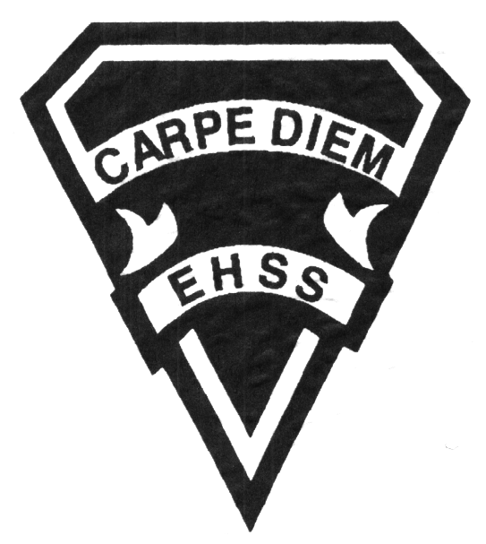

### 2018 – 2019

### Grade 12, University Preparation

### Calculus and Vectors

## MCV4U1

### 

###### Evaluation Profile & Outline

## Earl Haig

SecondarySchool

**Course Description/Rationale/Overview:**

This course builds on students’ previous experience with functions and their developing understanding of rates of change. Students will solve problems involving geometric and algebraic representations of vectors and representations of lines and planes in three-dimensional space; broaden their understanding of rates of change to include the derivatives of polynomial, sinusoidal, exponential, rational, and radical functions; and apply these concepts and skills to the modeling of real-world relationships. Students will also refine their use of the mathematical processes necessary for success in senior mathematics. This course is intended for students who choose to pursue careers in fields such as science, engineering, economics, and some areas of business, including those students who will be required to take a university-level calculus, linear algebra, or physics course.

**Class Requirements:**

Calculator (scientific, not graphing)

Textbooks:

Calculus and Advanced Functions

A deposit cheque in the amount of $90,

signed but not dated, is required when the text is issued. The cheque is to be

made out to Earl Haig S.S.

Replacement textbook cost: $90.00

**Course Requirements/Department Policies**

Course Prerequisites: MHF4U

Arrangements for missed tests for valid reasons must be made ahead of time if known in advance, or the teacher must be contacted on the day of the test by phone (395-3210 ext. 20080) in case of illness or other unexpected absence. The student should be prepared to write the test immediately upon return to school.

Late assignments must be accompanied with a note signed by a parent or guardian stating the reason for late submission. The note must list the due date of the assignment and the actual date of submission.

**Marks will be deducted for late assignments, up to and including the full value of the assignment.** [Growing Success: Assessment, Evaluation, and Reporting in Ontario Schools, Ministry of Ontario, 2010, pg. 43.]

**Mathematical Process Expectations**

Problem Solving Connecting

Reasoning and Proving Representing

Reflecting Communicating

Selecting Tools and Computational Strategies

#### Assessment Strategies

Diagnostic Quizzes Homework Check

Diagnostic Tests Group Work

In-class Assignments Technology Based Tasks

Peer Assessments Observations

Class Participation/Interaction

Conferences/Interviews

**Learning Skills:**

* Responsibility
* Initiative
* Organization
* Independent Work
* Collaboration
* Self-regulation

**Curriculum strands:**

1. Rate of Change
2. Derivatives and Their Applications
3. Geometry and Algebra of Vectors

Achievement Categories and Weighting

Knowledge & Understanding 25%

Application 20%

Thinking 10%

Communication 15%

Tests are written by all students on the same day and are designed so that students in different class sections will write tests of essentially

equivalent difficulty.

**FINAL MARK**

Year’s Work: 70 %

Final Summative Evaluation 30 %

### 2018 – 2019

### Grade 12, University Preparation

### Calculus and Vectors

## MCV4U1

## Earl Haig

SecondarySchool



1. **Rate of Change**
2. Demonstrate an understanding of rate of change by making connections between average rate of change over an interval and instantaneous rate of change at a point, using the slopes of secants and tangents and the concept of the limit.
3. Graph the derivatives of polynomials, sinusoidal, and exponential functions, and make connections between the numeric, graphical, and algebraic representations of a function and its derivative.
4. Verify graphically and algebraically the rules for determining derivatives; apply these rules to determine the derivatives of polynomial, sinusoidal, exponential, rational and radical functions, and simple combinations of functions; and solve related problems.
5. **Derivatives and their Applications**
6. Make connections, graphically and algebraically, between the key features of a function and its first and second derivatives, and use the connections in curve sketching.
7. Solve problems, including optimization problems, that require the use of the concepts and procedures associated with the derivative, including problems arising from real-world applications and involving the development of mathematical models.
8. **Geometry and Algebra of Vectors**
9. Demonstrate an understanding of vectors in two-space and three-space by representing them algebraically and geometrically and by recognizing their applications.
10. Perform operations on vectors in two-space and three-space, and use the properties of these operations to solve problems, including those arising from real-world applications.
11. Distinguish between the geometric representations of a single linear equation or a system of two linear equations in two-space and three-space, and determine different geometric configurations of lines and planes in three-space.
12. Represent lines and planes using scalar, vector, and parametric equations, and solve problems involving distances and intersections.

**Outline**