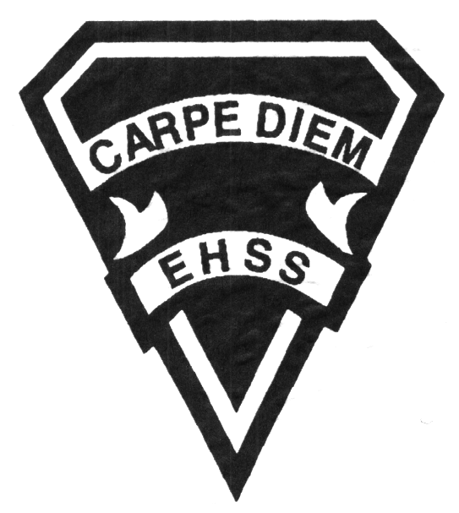

## Earl Haig

SecondarySchool

### AWM 3MP

##### Grade 11 Majors

**Visual Arts**

# **AWM 3MP**

**Evaluation Profile & Outline**

**Course Description/Rationale/Overview:**

This course enables students to further develop their knowledge and skills in visual arts. Students will explore and experiment with a variety of traditional and emerging media and technologies. A body of process and analytical work will be developed through their sketchbooks. Students will make connections between various works of art in personal, contemporary, historical and cultural contexts.

**Assessment and Evaluation Strategies**

Diagnostic, formative and summative: Rubrics

**Assessment:**

Student/teacher conferencing, group and self critiques, self/teacher check lists, observational assessments by teacher.

Artist statements, reflective writing and documentation of all process work.

**Evaluation:**

Process work, final projects/pieces, art history tests and quizzes, research assignments, art history presentations, in class and at home assignments.

**Class Requirements:** Materials/textbooks/equipment

Visual Arts Kit: See attached handout for specific materials required.

All kit materials will be provided for purchase in September in the Visual Arts department. (Date to be announced)

**Late and/or Missed Evaluation**

Our policy on late assignments as well as missed presentations and essays is in complete agreement with the school-wide policy. This policy adheres to Growing Success (Pg. 43-36). Late assignments must be accompanied with a note signed by a parent or guardian, stating the reason for the tardiness of the assigned work. The note must specify the due date and the actual date of the submission. Should an assignment be handed in after it has been taken up/handed back, the student may not receive a mark for it.

**Subject-Specific/Department Information**

**Attendance & Punctuality:** Attending all classes is mandatory as much of this course is studio driven. During class time, students are instructed (through demonstrations) on specific techniques and processes necessary for completing their works successfully. All classes begin with crucial lessons and hands on demonstrations. Lateness results in missed information. As well, it is disruptive and disrespectful to the class as a whole.

**Student leadership and exhibitions:** Canadian Art Foundation’s Ambassadorship Program, CAF’s Gallery Hop, The Grade 11 Collaborative Project,ongoingWave Galley exhibits, student-curated exhibits, and May Visual Arts off-site exhibition.

**Learning Skills\***

**Responsibility** – meets deadlines; takes responsibility for own behaviour

**Organization** – establishes priorities and manages time; uses information, technology and resources top complete tasks time management

**Independent Work** – follows instruction with minimal supervision; uses class time appropriately to complete tasks

**Collaboration** – accepts an equitable share of work in a group; builds healthy peer relationships; works with others to achieve group goals

**Initiative** – looks for opportunities for learning; demonstrates curiosity; approaches new tasks with a positive attitude

**Self-regulation** – sets own goals and monitors own progress; seeks assistance with needed; makes an effort with responding to challenges

###### Final Mark

**Year’s Work 70%**

Sketchbooks, studio work, projects, take home assignments, artist statements, essays and presentations.

**Final Summative Evaluation 30%**

Final project – Self-directed concept-based artwork, theme is chosen by the student with intense consultation with the teacher (in class assignment, process work, artist statement and critique).

**Achievement Categories and Weighting**

* **Knowledge / Understanding 25 % (Creating & Presenting)**: knowledge of facts and terms; understanding of concepts, principles, guidelines and strategies; understanding of relationships among concepts.
* **Application 40 % (Creating & Presenting)**: Processes, techniques and technologies. Final pieces ready for show.
* **Thinking Inquiry 25 % (Reflecting, Responding &Analyzing):** Formulating questions; planning, selecting strategies and resources; analyzing and interpreting information, and forming conclusions.
* **Communication 10 % (Foundations)**:Communication of information and ideas, communication for different audiences, use of various forms of communication.

*From: Ontario Ministry of Education. *Growing Success: Assessment, Evaluation, and Reporting in Ontario Schools*. Toronto: Ministry of Education, 2010, 11.



**Course Outline/Curriculum Strands:**

**Creating & Presenting**

**A1. The Creative Process:** apply the creative process to create a variety of art works, individually and/or collaboratively;

**A2. The Elements and Principles of Design: apply** the principles of design to create art works for the purpose of self-expression and to communicate ideas, information, and /or messages;

**A3. Production and Presentation:** produce art works, using a variety of media/materials and traditional and/or emerging technologies, tools, and techniques, and demonstrate and understanding of a variety of ways of presenting their works and the works of others.

**Reflecting, Responding, and Analysing**

**A1. The Critical analysis Process:** demonstrate an understanding of the critical analysis process by examining, interpreting, evaluating, and reflecting on various arts works;

**A2. Art, Society, and Values:** demonstrate an understanding of how art works reflect the society in which they were created, and how they can affect personal values;

**A3. Connections Beyond the Classroom:** demonstrate an understanding of the types of knowledge and skills developed in visual arts, and identify various opportunities related to visual arts.

**Foundations**

**A1. Terminology:** demonstrate an understanding of, and use correct terminology when referring to, elements, principles, and other components related to visual arts;

**A2. Conventions and Techniques:** demonstrate an understanding of the conventions and techniques used in the creation of visual art works;

**A3. Responsible Practices:** demonstrate an understanding of responsible practices related to visual arts.

**Title of Unit/Strand 1: Landscape**

1. *Drawing: Landscape abandoned*
2. *Independent Study Project: Landscape*

*I. An in depth look at the role and use of landscape depictions in both Western and non- Western art. Original photography of structures within various landscapes as well as outdoor “en plein air” sketches will be employed as process for a technical drawing. Drawings will be executed with graphite and pencil crayon on paper.*

*II. The notions of personal, public and “place of” one’s self in space will be discussed and employed in the final piece. Students will first propose, then create, critique and present their final work(s) through an artist talk. Media is open as are the number of pieces generated in the exploration of Landscape as a theme.*

**Title of Unit/Strand 2: Neo-Expressionist Painting**

*Independent Study Project: Childhood*

*This unit is an exploration of mixed media and the significance of mark making in contemporary painting by way of examining Neo-expressionism. Imagery derived from childhood drawings and painings, along with colour theory, collage, photography and various painting techniques will be explored as process for creating a large-scale painting as the culminating task.*

*Students will first propose, then create, critique and present their final work(s) through an artist talk.*

**Title of Unit/Strand 3: Art History**

*Art History: Isms Presentation*

*A continuation from the grade 10 time line; all movements following Rococo, leading up to contemporary (post modernism) will be addressed, analyzed and discussed in this unit. Students research and independently present a 15 minute power point presentation on one of 22 “isms” in the development of western art.*

**Title of Unit/Strand 4: Illustration**

*Commercial illustration for children’s books*

*Students will be introduced to specific illustration techniques as well as various surfaces and styles. Each week of this unit, they will be assigned a given text from a nursery rhyme and sked to illustrate it with very specific criteria. They will implement learned techniques, using various materials and surfaces in completing their pieces as free-lance illustrators.*

### AWM 3MP

##### Grade 11 Majors

**Visual Arts**

# **AWM 3MP**

**Evaluation Profile & Outline**

## Earl Haig

SecondarySchool