Computer Science/Engineering program at EHSS is a 21st century learning experience to help students develop the foundational ICT skills needed to design programs, build, and manage computers and computer networks, along with career skills such as problem solving, electronic collaboration, and critical thinking.
In addition to earning school credits, students receive Python Certification from Python Institute, Cisco Certification, C++ Certification from C++ Institute and SAS Certification from SAS academy.

Analytics, Artificial Intelligence …
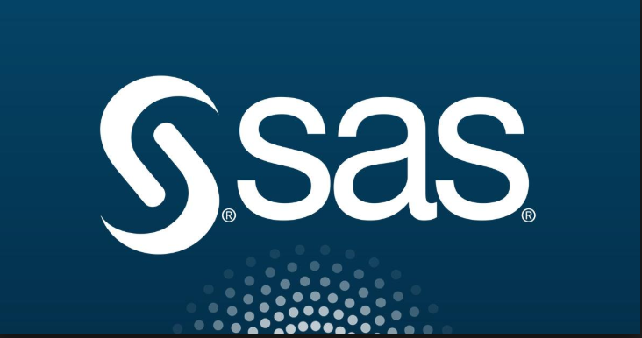

TEJ2O1- Computer Engineering Grade 10
Pre-requite(s): NONE
This course covers the fundamentals of computer hardware and software and advanced concepts such as security, networking, and the responsibilities of an IT professional. Students are enrolled in CISCO Academy and work towards IT Essentials certification. In semester 2, students design circuits using that control trafic lights, motion detector using arduino …

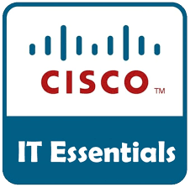 | 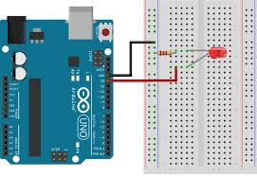 | 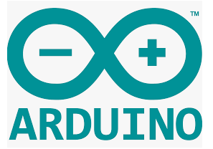

TEJ3M1- Computer Engineering Grade 11
Pre-requite(s): NONE
This course examines computer networks and computer systems and its role in controlling and providing digital communication. Students will develop knowledge and skills in electronics, robotics, programming of network devices, and will build networks that use computer programs and network interfaces to control device excess and traffic. Students will learn about programs leading to careers in computer networking and its social and environmental aspects. The course is based on CISCO Academy and prepares students for CCNA 1 and 2 certifications.

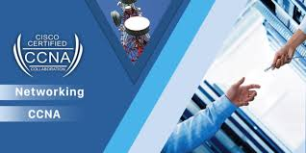 | 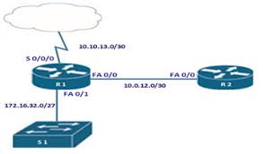

ICS2O1- Introduction to Computer Studies 10
Pre-requite(s): NONE
This course introduces students to computer programming. Students will plan and write simple computer programs by applying fundamental programming concepts, and learn to create clear and maintainable internal documentation. They will also learn to manage a computer by studying hardware configurations, software selection, operating system functions, networking, and safe computing practices. Students will also investigate the social impact of computer technologies, and develop an understanding of environmental and ethical issues related to the use of computers.
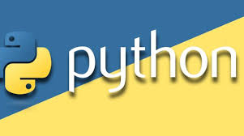 | Why Python?  - an easy and intuitive language just as powerful as those of the major competitors;  - open source, so anyone can contribute to its development;  - code that is as understandable as plain English;  - suitable for everyday tasks, allowing for short development time

ICS3U1 – Introduction to Computer Science 11
Pre-requite(s): NONE
Students will design software independently and as part of a team, using industry-standard programming tools and applying the software development life-cycle model. They will also write and use subprograms within computer programs. They will also explore environmental and ergonomic issues, emerging research in computer science, and global career trends in computer-related fields.

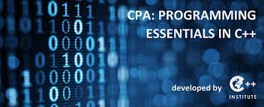 | 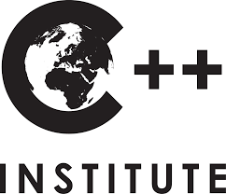

ICS4U – Computer Science Grade 12 University
Pre-requite(s): ICS3U (Grade 11 computer science)
Students will study advanced programming theory using Object Oriented programming language – such as C++, SAS and standard documentation approaches. This course will also center on the development of software utilizing OOP concepts. A research component will investigate issues pertaining to Internet of Everything, the ethical use of data and the use of information and its impact in the community. Student will have the opportunity to use their own device using Xcode to develop app for their final summative .

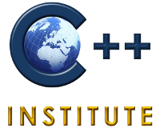 | 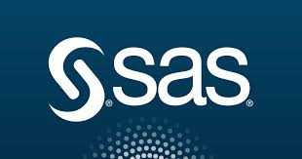 | 